 | Weekly Insights | Nov 6, 2025
 | Item | Page
 | Stories of the Week | 1
 | Corn | 30
 | Wheat | 32
 | Soybeans | 34
 | Soybean Meal | 36
 | Soybean Oil | 38
 | Weekly Prices | 40

Executive Summary
Corn – Flat Futures, Carry Firms as CIF Bids Climb
December corn climbed 2¢ to $4.34/bu, trading in a narrow range as solid export inspections and Gulf basis gains offset harvest pressure. The Dec/Mar spread narrowed to 14.25¢ (71 percent of full carry), its firmest in over a month, as exporters chased near-term supply. CIF basis strengthened 5–7¢ on strong Gulf demand, while river markets improved where barge traffic normalized. Weekly inspections reached 1.69 MMT for the week ending Oct 30, more than double last year’s volume and contributing to the rise in the December contract to the upper end of the range in which it has been trading since June.

Soybeans – Modest Rally on Trade Optimism, Basis Softens at Gulf
January 2026 soybeans rose 32¢ to $11.24/bu, notching a one-year high on expectations that China might resume purchases after a Nov 10 tariff rollback. Gulf basis eased 3–5¢ on soft Chinese offtake, while Jan/Mar held near 11¢ (59 percent of full carry) as crushers remained active. Export inspections slipped to 0.96 MMT (–9 percent w/w), reflecting delays in recent bookings. Processor bids held steady at +20 to +30¢ across much of the Midwest.

Wheat – Futures Extend Gains on Plains Dryness, Spreads Steady
December SRW wheat gained 21¢ to $5.53/bu (+4 percent), continuing its recovery on dry conditions in HRW regions and fund short-covering. The Dec/Mar spread narrowed to 13¢ (68 percent of full carry), while FOB premiums remained wide vs. Black Sea origins. Russian 12.5 percent offers firmed another $3–5/mt, and U.S. inspections rebounded to 350k mt, though still lagging seasonal targets.

(Carry % calculated assuming 6% annual interest and \$0.05/bu per month storage/insurance cost over the spread interval.)

Macro/Policy – China Tariff Shift in Focus, Dollar Flat, Crude Eases
Markets traded cautiously ahead of China’s Nov 10 rollback of retaliatory tariffs on select U.S. ag products. Corn and wheat are now exempt from additional duties, while soybeans remain subject to the 13 percent MFN tariff. U.S. officials indicated China may purchase up to 12 MMT of U.S. soybeans by year-end, with informal targets of 25 MMT for 2026, though no official agreement has been confirmed. The U.S. Dollar Index held near 100.1, the Brazilian real hovered around 5.40, and crude oil eased to $60.32/bbl (–1.5 percent w/w), modestly pressuring biofuel margins.
Weather – Harvest Wraps in U.S., Brazil Rains Uneven, Argentina Stable

Corn harvest in the United States reached approximately 83 percent complete, while soybean harvest advanced to near 91 percent, supported by dry weather across much of the Midwest that allowed for rapid progress. Recent rainfall in the Ohio and Lower Mississippi Valleys helped raise river levels slightly, improving barge movement after a constrained October. In Brazil, scattered rains brought some relief to Mato Grosso and Goiás, allowing soybean planting to resume in areas that had stalled. However, soil moisture across much of the Central-West remains below normal, and consistent rainfall is still needed to sustain crop establishment. In Argentina, conditions were mostly dry but remained cool, which helped preserve early-season soil moisture and supported steady corn planting progress.
What’s Next (Oct 30 – Oct 6):
China Tariff Implementation: Markets watching for flash corn/wheat sales after Nov 10 removal of retaliatory tariffs
Brazil Forecasts: Continued rains needed in Central-West to sustain planting pace
USDA WASDE (Nov 14): Expectations for minor corn/soy yield revisions and export updates
Export Reports: Weekly inspections will remain key as USDA sales reports catch up post-shutdown
Ethanol Data (Nov 6): EIA to confirm whether production holds above 1.1 mbpd
River Logistics: Monitor water levels and barge freight after recent improvement.
Table A – CME Futures (Front Contracts)
(Prices in USD per bushel, volume/open interest in contracts)
Contract (Front Month) | 10/29/2025 Close | 11/05/2025 Close | Change (Δ) | Δ% | 5-day Realized Vol* (x) | Open Interest Δ  (x)
Corn (Dec ’25) | $4.32 | $4.34 | +$0.02 | +%0.6 | 12% (ann.) | -3k (est.)
Soybeans (Jan ’25) | $10.92 | $11.24 | +$0.32 | +%3.0 | 12% (ann.) | +3k (est.)
Wheat (Dec ’25) | $5.32 | $5.53 | +$0.21 | +%4.0 | 12% (ann.) | 0k (est.)
5-day realized volatility estimated from daily settlement price changes.
Actual contract open interest changes are estimated; total corn OI rose slightly as new-crop hedges built, while wheat OI fell with Sep contract deliveries.
Table B – Key Calendar Spreads & % of Full Carry
Spread (Crop ‘25→‘26) | 10/29  Quote | 11/05  Quote | Δ (carry) | % Full Carry* | Market Implication
Corn Dec–Mar | -$0.13 | -$0.14 | +0.01 | 71% | Nearby Gulf demand firming vs. interior harvest flow
Soy Jan–Mar | -$0.11 | -$0.11 | +0.00 | 59% | Crush pull holding January, export sales still Brazil-facing
Wheat Dec–Mar | -$0.15 | -$0.13 | +0.02 | 68% | Black Sea supply caps U.S. exports pace, carry remains commercial
Assumes 7% annual interest + $0.05/bu/month storage/insurance. Full carry (3 months) ≈ $0.22–$0.23 for corn & SRW wheat; (2 months) ≈ $0.22 for soybeans. % of full carry = (calendar spread ÷ calculated full carry).
Table C – Notable International Futures (weekly moves, if significant):
Exchange (Front Mo) | 10/29 USD Price | 11/05 USD Price | Δ% | Notes
Dalian Corn (Jan) | ¥2,115($7.55/bu) | ¥2,141($6.40/bu) | +1.2% | China corn futures steady on moderate feed demand; premium over import parity due to quotas.
Dalian Soymeal (Jan) |  | ($11.84/bu) | +0% | Soy meal eased; steady hog demand amid stable inclusion rates, but supply pressure weighs.
  ¥3,100
  ($11.84/bu)
  ¥3,100
B3 (São Paulo) Corn (Nov) |  |  | -4.7% | Brazilian corn softened on steady domestic logistics and U.S. competition, export pace firm.
  R$64.68
  ($12.00)
  R$64.68
  ($11.85)
Euronext Wheat (Dec) |  |  | +2.1%
  €190 ($220)
  €194 ($221.46)
  EU wheat held steady amid ample stocks and slow demand, capped by cheap Black Sea offers.

Corn Market Deep Dive
Futures & Spreads: December 2025 corn futures closed on the week at $4.34/bu, marking a 2¢ gain from the prior Wednesday but unchanged from Oct 29. Price action was subdued, with early week firmness on soybean-led optimism fading into midweek resistance at $4.35. The Dec ’25–Mar ’26 spread narrowed to 14¢ carry, equivalent to roughly 71 percent of full commercial carry using a six percent interest rate and $0.05/bu/month storage and insurance assumptions. This was the firmest front spread since late September and reflects improved nearby demand into the Gulf and ethanol channels. Realized 5-day volatility stayed low near 12 percent annualized, with options skew stable and no sign of directional conviction. The modest carry compression occurred despite flat futures, signaling basis-led strength underneath the board.
Funds & Positioning: CFTC Commitment of Traders data remained unavailable this week due to the federal shutdown. However, CME open interest in December corn was down modestly (3,000 contracts) week-over-week, with no clear sign of new fund positioning. Market tone suggests light short-covering in the front month, with some spread roll activity into March. Commercial hedging appeared active in the deferred curve, but total corn OI was stable, implying a balanced flow between longs and shorts. With no major trend trigger, funds likely remain net short but cautious ahead of November WASDE and potential Chinese re-entry post-tariff relief.
U.S. Cash & Basis: CIF Gulf basis climbed to +94¢ over December futures, up 5–7¢ from the prior week, supported by strong vessel lineups and brisk loadings for Mexico and Latin America. The Mississippi River system showed improvement in barge flow after rains in the Ohio Valley lifted water levels, easing freight rates modestly. On the Illinois River, basis edged up to –28¢ under Dec, while the Ohio River held near –20¢. In the Lower Miss, basis rebounded to –50¢ to –60¢, a 10¢ improvement week-on-week, as logistics loosened. Interior ethanol plants in Iowa and Nebraska maintained steady bids at +10¢ to +15¢ over, reflecting solid grind margins with ethanol production holding near 1.12 mbpd. National basis was estimated near –39¢ under, 2¢ firmer than last week based on trade feedback and broker composites. The interior-to-Gulf spread tightened slightly, reinforcing the demand pull into export and processor channels.
Export Flows: USDA FGIS reported corn export inspections at 1.6 MMT for the week ending Oct 30, the highest weekly total this marketing year and more than double year-ago levels. Loadings were concentrated at the Gulf, with Mexico, Colombia, and South Korea among primary destinations. Despite stronger flows, U.S. FOB offers near $198/MT ($5.02/bu) remained about 20¢/bu above Brazilian values into East Asia. CIF strength and barge costs still limit forward Gulf competitiveness, but demand within the Americas stayed active. USDA export sales reporting remained suspended; private estimates suggested ~800k–900k MT in new corn bookings, though unconfirmed.
International Trade: Brazilian FOB corn at Santos held around $205/MT ($5.20/bu equivalent), keeping a slight edge over the U.S. Gulf into Asia. ANEC’s final October corn export total reached approximately 6.19 MMT, up from 5.67 MMT in October 2024. Brazilian exports are beginning to seasonally wind down. Interior prices in Mato Grosso were flat at BRL 46 per 60kg sack, with farmer selling subdued. Argentina’s Up-River FOB corn was offered near $180–185/MT, undercutting the U.S. Gulf into some EU and MENA destinations. Rosario’s corn planting progress reached 50 percent as of Nov 1, ahead of average, with analysts projecting a record 61 MMT harvest if El Niño weather holds. In China, Dalian corn futures (Jan) rose modestly to ¥2,141/MT ($6.44/bu equivalent), keeping domestic prices well above import parity. With China’s retaliatory tariff on U.S. corn set to expire Nov 10, U.S. Gulf corn could regain traction in that market assuming political follow-through. No confirmed Chinese corn purchases occurred this week, but traders reported active inquiries.
So What? Corn futures treaded water, but the market’s foundation improved. The Dec/Mar spread firmed to the tightest level in five weeks, CIF basis rallied, and barge logistics improved, all signs of robust nearby demand. Export inspections surged and ethanol grind remains solid, yet flat price failed to respond due to heavy harvest availability and lack of major fund rebalancing. Until either Chinese buying materializes or WASDE revises demand upward, December corn likely oscillates within a $4.20–$4.40 range. In the meantime, basis and spreads remain the clearest indicators of direction, and both are currently leaning supportive.

Soybean Market Deep Dive
Futures & Spreads: January 2026 soybeans ended the week around $11.24/bu, up roughly 32¢ or three percent from October 29, supported by optimism surrounding U.S.–China trade discussions and weather-driven uncertainty in Brazil. The January–March 2026 spread held a modest 5.5¢ carry, about 30 percent of full commercial carry assuming six percent annual interest and five cents per bushel monthly storage and insurance. The curve retained a mild upward slope, with no sign of nearby tightness. Volatility stayed contained, and trade volume suggested commercial hedging rather than speculative pressure.
Products & Crush: Board crush margins remained comfortably positive as processors continued to benefit from firm domestic meal demand and steady oil yields. Soybean oil eased in line with weaker crude prices, while meal prices were steady to slightly higher, keeping gross crush margins above historical averages and plants running near capacity. Private estimates suggested October crush volumes likely exceeded last year’s pace, although official data were not released within the window.
Funds & Positioning: CFTC positioning data were still unavailable due to the government shutdown, but CME open interest rose modestly over the week. The increase appeared tied to roll activity and end-user hedging rather than new fund buying, consistent with the absence of inversion and the limited export pull from China. The futures curve reflected a steady nearby market supported mainly by processors rather than speculative demand.
Cash & Basis: Processor bids in the Midwest and Eastern Corn Belt remained firm between 60 and 75 cents over January futures, underpinned by strong meal offtake. Gulf basis eased slightly to around 80 cents over, as Chinese spot demand stayed quiet. River bids improved modestly where barge drafts recovered after October rains, while areas farther north remained soft. The national average basis was close to 70 cents under, little changed week over week, reflecting balanced supply and demand across regions.
Trade Flows & International Competition: USDA inspections for the week ending October 30 totaled roughly 0.96 MMT, down from the prior week and about 40 percent below the same period last year. Brazil continued to dominate China’s nearby purchase program, with exporters shipping an estimated seven million tonnes of soybeans in October. Brazilian FOB values near 490 dollars per tonne remained about 10 to 15 dollars cheaper than the U.S. Gulf, maintaining Brazil’s edge into Asian destinations. Argentina’s export pace was moderate as crushers absorbed most available supply, while China’s private importers booked several Brazilian cargoes for December and March through mid-year 2026 delivery.
Policy Context: Beijing’s tariff rollback effective November 10 excluded soybeans, which remain subject to the 13 percent MFN duty. Reports of a potential framework for Chinese purchases of 12 million tonnes in 2025 and 25 million tonnes in 2026 circulated in trade channels, but no formal agreement or daily sales confirmations have been released. Market participants viewed these figures as guidance rather than binding commitments, awaiting official announcements or verified sales to validate the outlook.
So What? t’s still a split tape: crushers are steady buyers and keep the front carry small, but exports remain Brazil-centric, capping Gulf basis and keeping U.S. futures from breaking out. With Jan/Mar carrying only a few cents and inspections subdued, futures likely chop in the low-$11s unless Brazil’s Central-West rains falter again, or the rumored China purchase program converts into confirmed daily U.S. sales. Until then, basis and spreads do the heavy lifting under the board, and right now they argue for support, not scarcity.

Wheat Market Deep Dive
Futures & Spreads: Chicago SRW December 2025 futures rose 21¢ on the week, closing near $5.53/bu, a four percent rise that extended last week’s recovery. Gains were primarily technical, led by fund short-covering and modest spillover from soybeans and corn. The December–March 2026 spread narrowed slightly to about 15¢ carry, roughly 68 percent of full carry when assuming a six percent interest rate and $0.05/bu per month storage and insurance. The structure still rewards storage, though less than earlier in October as interior cash markets stabilized. KC HRW December rose 11¢ to $5.80/bu, supported by ongoing dryness in western Kansas and Oklahoma, while Minneapolis HRS December added 7¢ to $6.22/bu. Realized volatility remained near 20 percent, with speculative positioning still light and sentiment improving from deeply oversold levels.
Global Supply & Demand: Russian 12.5 percent wheat FOB offers firmed to roughly $240/MT, up $3–5 on the week, reflecting seasonal tax adjustments and a steadier ruble. Despite firmer values, Russia maintained dominant pricing power into North Africa and the Middle East, securing multiple GASC and Turkish tenders. French wheat (Rouen) traded near $230/MT but continued to lose share to Black Sea origins. The European crop outlook remained stable with 69 percent of French wheat rated good to excellent heading into dormancy. Argentina’s crop estimate held near 16.5–17 MMT, as recent moisture offset earlier frost damage. In Australia, late-season showers improved harvest prospects slightly in the east but were too late to reverse prior yield losses in Western Australia. In the United States, HRW planting was around 91 percent complete, with 52 percent rated good to excellent. However, the southern Plains stayed mostly dry, and early emergence remained patchy in parts of Kansas and Texas, providing mild support to HRW spreads and premiums.
Cash & Basis: U.S. FOB SRW Gulf offers hovered near $230/MT ($6.85/bu equivalent), still about $20–25/MT above Russian competition into North Africa and Southeast Asia. HRW FOB values near $243/MT reflected freight and protein premiums but remained uncompetitive globally. Gulf export basis eased slightly, down 1–2¢, amid limited loading programs. Domestic milling basis in the southern Plains was flat to weaker as mills remained well covered through December, with Oklahoma and Texas bids 2–3¢ lower on the week. Interior basis in Kansas and Nebraska stayed soft around 45–55¢ under December futures, consistent with full-carry storage economics and slow downstream demand. The premium for high-protein HRW over SRW widened slightly as millers favored quality coverage heading into winter.
Trade Flows: USDA inspections for the week ending October 30 reached 350k tonnes, up from 259k the previous week but still well below typical seasonal volumes. The rebound reflected improved loadings out of the Gulf, though U.S. export competitiveness remains constrained by price. Russia continued to dominate global tender business, and Ukraine maintained steady shipments via Danube routes despite logistical risks. The EU held stable export momentum, while Argentina’s wheat shipments will begin to enter the market in December. No flash sales were reported from the United States, and USDA’s weekly export sales report remained delayed by the government shutdown.
Speculative Positioning: CFTC data remained unavailable, but CME open interest in SRW futures was little changed, consistent with light fund short covering. Commercial hedging interest in deferred months increased modestly as elevators captured carry. Overall participation stayed thin, with speculative players largely focused on corn and soybeans. Price action continued to reflect short-term technical recovery rather than a shift in market fundamentals.
So What? U.S. wheat remains the follower in global trade, benefiting temporarily from short-covering and weather concerns but still priced out of key tenders. Russian supply continues to anchor global values, and spreads confirm that the U.S. market remains in a comfortable carry structure with limited nearby demand. Unless Russian export logistics tighten, Southern Hemisphere harvest issues deepen, or a weaker dollar improves competitiveness, U.S. wheat is likely to hold within a narrow range. For now, wheat’s strength is technical, not structural, with fundamentals still shaped by global abundance and external market cues rather than domestic demand.

U.S. Cash Market & Basis
Corn: River basis improved modestly this week as late-October rainfall lifted water levels along key stretches of the Mississippi and eased freight costs. Illinois River bids firmed to around 28¢ under December futures, up 4¢ from the prior week, while the Lower Mississippi strengthened to 50–60¢ under as barge drafts normalized. Spot freight from Cairo to Memphis declined toward $16–17/ton, down from roughly $20/ton a week earlier. CIF Gulf basis advanced to 94¢ over, supported by active export loadings to Mexico and Latin America and improved vessel lineups. Processor bids in Iowa and Nebraska held steady between even money and 15¢ over, consistent with solid ethanol margins and stable feed demand. The national average corn basis was near 39¢ under, roughly 2¢ firmer on the week, reflecting a mild rebound in river markets while interior bids stayed anchored by ample on-farm stocks.
Soybeans: Gulf basis eased slightly, with CIF bids retreating to 83¢ over January futures, down 2–3¢ from last week, as export pace slowed and Chinese buying remained limited. River bids were mixed: Illinois River locations edged higher to roughly 30¢ under January, while the Lower Mississippi improved to 70–72¢ under amid better barge movement. Processor bids in the Eastern Corn Belt stayed firm, with Indiana and Ohio plants maintaining levels between 60 and 75¢ over, supported by strong crush margins and steady meal offtake. Western processors, particularly in Iowa and Minnesota, were steady near 50¢ over. National average soybean basis was close to 68¢ under, little changed week to week, as firm crush demand offset weaker export channels.
Wheat: U.S. FOB offers remained broadly uncompetitive against Black Sea origins. HRW 11.5 percent protein wheat held near $243/MT ($6.90/bu equivalent) and SRW around $230/MT ($6.85/bu), both steady on the week. Gulf export basis eased by roughly one cent on light demand and limited barge activity. Milling bids across the Southern Plains remained flat to slightly weaker, with Oklahoma and Texas down 2–3¢ as mills remained well covered into December. Elevators across Kansas and Nebraska continued to post nominal interior basis, driven primarily by carry structure rather than nearby consumption. Domestic demand from millers stayed quiet, reflecting stable flour production and minimal new spot coverage needs.
So What? Basis patterns stabilized as river logistics improved and export movement resumed more fluidly through the Gulf. Processors maintained firm bids thanks to healthy margins, while exporters benefited from easing barge costs but still faced global price competition. The mild firming in corn and soybean basis suggests demand is keeping pace with post-harvest flow, even as large supplies and storage incentives keep the market well supplied. Until Chinese demand expands or global freight differentials narrow, domestic processors will remain the primary driver of nearby cash strength.

International Cash & Trade Flows
Brazil: Brazil maintained its lead in global corn and soybean trade, though October export volumes came in slightly below early-month expectations. ANEC reported October soybean exports of about 7.0 MMT, still well above last year but trimmed from initial projections as some late cargoes rolled into November. Corn shipments totaled roughly 6.19 MMT, down from the prior month but consistent with record second-crop output. FOB Santos soybean offers averaged $486–$490/MT ($11.15–$11.25/bu), keeping a 10–15 dollar per tonne discount to the U.S. Gulf, while corn FOB values near $205/MT ($5.20/bu) stayed price leader into Asia. Paranaguá and Santos lineups remained active, with China and Southeast Asia continuing to dominate destinations. In the interior, Mato Grosso soybean planting advanced to about 47 percent as early rains improved field conditions, although subsoil moisture in central Brazil remains below normal. Domestic logistics and barge flows stayed fluid, preventing major congestion despite uneven rainfall across the Center-West.
Argentina: Argentina’s Up-River FOB corn was offered around $180–185/MT, while soybeans and soymeal were near $430–435/MT, each down slightly from late October. Farmer selling slowed again following the expiration of temporary tax incentives and ahead of the November 24 runoff election. Rosario’s crushers maintained steady throughput, supported by stocks accumulated during September’s “soy dollar” window. Corn planting reached about 50 percent of projected area, well ahead of last year, with improved soil moisture supporting a record harvest outlook of around 61 MMT if El Niño weather persists. The peso continued to weaken, with the informal rate near 1,450 per U.S. dollar, sustaining export incentives despite uncertainty over post-election policy adjustments. Wheat harvest began in northern provinces under mostly favorable weather, with national production estimates still near 16.5–17 MMT.
China: China’s import behavior remained cautious. U.S. Gulf soybeans were offered at roughly $2.40 per bushel over January futures, about 15 cents higher than equivalent Brazilian cargoes, keeping Brazil as the preferred origin for November and December shipments. Chinese crushers booked additional Brazilian parcels for nearby positions, while reported purchases of U.S. beans were limited and largely unconfirmed. Dalian corn futures for January traded near ¥2,141/MT ($6.40/bu equivalent), still well above landed import parity, leaving imported corn uncompetitive without tariff exemptions. The November 10 tariff rollback will remove additional retaliatory duties on U.S. corn, wheat, and sorghum, but soybeans remain subject to the 13 percent MFN rate. Reports of a framework for future Chinese soybean purchases, 12 million tonnes for 2025 and 25 million tonnes for 2026, circulated this week, but no official agreement or daily sales were confirmed. Market participants are waiting for evidence of follow-through before repricing demand expectations.
EU / Black Sea: Russian 12.5 percent protein wheat FOB offers strengthened further to about $240/MT, up three to five dollars from last week, as export taxes adjusted higher with currency stabilization. Despite that, Russian shipments to North Africa and the Middle East remained brisk, keeping global wheat values anchored. French wheat offers from Rouen were near $230/MT, while export interest was subdued after recent Algerian and Moroccan tenders. Ukrainian corn exports through the Danube and rail corridors continued steadily, with competitive offers around $205–210/MT into Mediterranean buyers. The EU’s internal feed grain balance remained comfortable, and imports slowed seasonally as local harvest wrapped up. Russian and Ukrainian soymeal continued to make inroads into MENA and Southern Europe markets at the expense of U.S. product, supported by lower freight and a softer ruble.
Other Origins: No major shifts occurred in Canada or South Africa. Canadian spring wheat exports into Mexico and Asia continued at a modest pace, while Ukraine’s logistics remained stable under the current corridor arrangements. Australian wheat harvest began in eastern regions, with quality expected to be variable after earlier dryness. India remained absent from international grain markets, and no new trade policy announcements were issued from the region.
So What? Global trade remains led by Russia in wheat and by Brazil in corn and soybeans, while Argentina’s political calendar introduces short-term uncertainty without shifting fundamentals. China’s limited engagement with U.S. supply and preference for cheaper Brazilian offers continue to weigh on Gulf competitiveness. With freight and FOB differentials still wide, U.S. exporters face difficulty regaining share. Until tariff advantages or logistical costs narrow meaningfully, domestic spreads and basis will keep favoring storage and deferred ownership over near-term movement.
Key Fundamentals & Reports (Oct 30 – Nov 5)
Government Data & Reporting: The U.S. government shutdown continued through the first week of November, extending into its 36th day and keeping USDA, CFTC, and other agency data releases suspended. No official updates were published for export sales, crop progress, or fund positioning. Only fee-based and independently operated datasets, such as USDA FGIS inspections, EIA ethanol reports, and international trade figures from ANEC and BCBA, were available. USDA confirmed that regular reporting schedules, including WASDE and Crop Production, will resume beginning November 14, when backlogged data will be consolidated. Market participants largely relied on private estimates and export lineup data for near-term guidance.
Crop Progress (estimated as of Nov 2): Private surveys and trade consensus indicated the U.S. corn harvest reached roughly 83 percent complete, while soybeans were near 91 percent, both comfortably ahead of the five-year averages of 68 and 78 percent, respectively. Dry and mild conditions across the Midwest allowed uninterrupted fieldwork through early November, with most producers in Illinois, Iowa, and Minnesota finishing harvest. In the central and southern Plains, winter wheat planting reached an estimated 91 percent completion, with 52 percent of the crop rated good to excellent. Emergence has been uneven in drier areas of Kansas and Oklahoma, but no major damage or frost losses have been reported.
Export Inspections (USDA FGIS – week ending Oct 30, published Nov 3): Corn inspections surged to 1.6 MMT, more than doubling last year’s comparable week and marking the strongest weekly volume of the marketing year. Mexico, Colombia, and South Korea were the primary destinations. Soybean loadings totaled about 0.96 MMT, down slightly from 1.06 MMT the prior week as Chinese purchases shifted toward Brazilian origins. Wheat inspections improved to 350k tonnes after last week’s 259k, though U.S. exports remain constrained by weak global competitiveness. Western Hemisphere demand continues to underpin corn and soy flows, while wheat trade remains limited to sporadic Latin American and Caribbean markets.
Export Sales (USDA FAS, not published): Weekly export sales data remained suspended, with the most recent release still covering the week ending September 18. In the absence of official figures, trade sources cited continued soybean sales activity to “unknown” destinations, widely assumed to be China, and scattered corn sales to Mexico and Japan. No major flash sales were reported during the window, though traders expect pent-up reporting to resume in mid-November.
Ethanol Production & Stocks (EIA – week ending Oct 31 / published Nov 5): Ethanol output increased sharply to 1.123 million barrels per day, up eight percent on the week and 1.6 percent above year-ago levels. Stocks rose to roughly 21.3 million barrels, about three percent higher year on year. The weekly grind implied roughly 107 million bushels of corn use, supporting firm bids at ethanol plants and steady basis in the Western Corn Belt. Margins remained profitable as corn prices stabilized and co-product values (DDGS) firmed modestly.
NOPA Crush: No new NOPA data were published within the window, but trade expectations point to another strong month of domestic processing. Private estimates suggest October crush likely exceeded the prior year’s pace, sustained by favorable board-crush margins and steady soymeal demand in the Eastern Corn Belt. Processor bids remained firm, consistent with positive margins despite soft export movement.
CFTC Commitments of Traders: No CFTC reports were released as of November 5. CME open interest changes indicated limited speculative repositioning: minor short-covering in corn, slightly higher hedging in soybeans, and little movement in wheat. Trade estimates continued to peg managed money net short around 45–55k contracts in corn, roughly 90–95k in wheat, and near flat to modestly long in soybeans. Absent official data, market direction remained anchored by physical flow and spread behavior rather than fund activity.
So What? U.S. harvest is effectively complete, and physical flow data continue to confirm strong corn and ethanol demand, steady domestic crush, and slow soybean exports. With official USDA and CFTC updates still offline, traders are leaning heavily on inspections, private shipment data, and basis signals to gauge momentum. Corn’s export strength and ethanol grind provided mild fundamental support, while soybeans stayed rangebound on weak China buying. Wheat remains globally oversupplied and uncompetitive. Until data releases resume and Brazil’s weather trend clarifies, short-term price direction will remain driven by export pace, logistics, and domestic processor activity rather than official government reports.

International Reports:
Brazil – ANEC & Weather Updates: Brazil maintained its dominant role in global grain trade. ANEC’s final October estimates confirmed soybean exports at roughly 7.0 MMT and corn exports near 6.19 MMT, both slightly below earlier projections due to delayed loadings in northern ports and vessel scheduling into November. FOB Santos soybeans averaged between $486 and $490/MT ($11.15–$11.25/bu), while corn values held steady near $205/MT ($5.20/bu), preserving Brazil’s pricing advantage over the U.S. Gulf into Asia. Mato Grosso soybean planting advanced to about 47 percent, up sharply from the previous week as early rains arrived, though cumulative October precipitation remained well below average. Forecast models indicated improving rainfall prospects through early November, particularly in the Central-West. Logistics through the BR-163 and major southern ports continued to run normally, with exporters sustaining strong flows to China and Southeast Asia. No new CONAB bulletins were issued during the week.
Argentina – Pre-Election Grain Sales & Planting Progress: Farmer selling slowed slightly following the end of the temporary zero-export-tax period on October 31. Up-River FOB values were steady to softer at $430–435/MT for soymeal, $430–435/MT for soybeans, and around $180–185/MT for corn, reflecting moderate demand and weaker forward coverage. Rosario’s crushers maintained steady operations, supported by stocks accumulated during September’s tax window. Corn planting reached approximately 50 percent of intended area by early November, ahead of last year’s drought-delayed pace, with favorable soil moisture supporting yield prospects. Wheat harvest began in northern provinces, with national output estimates holding near 16.5–17 MMT. The peso continued to depreciate in parallel markets, trading near 1,450 per U.S. dollar, which sustained export incentives ahead of the November 24 presidential runoff. No new reports were released from the Ministry of Agriculture or the Rosario Exchange during the week.
China – Trade Talks & Tariff Rollback: Market attention focused on the upcoming November 10 implementation of China’s tariff rollback on selected U.S. agricultural imports. The cuts will remove additional duties on corn, wheat, and sorghum but exclude soybeans, which continue to face the 13 percent MFN rate. U.S. officials indicated that China may purchase up to 12 MMT of U.S. soybeans in 2025, with informal targets of 25 MMT for 2026, though no formal agreement has been published. Chinese crushers remained primarily focused on Brazilian supply for November and December arrivals, with U.S. Gulf offers still about $10–15/MT higher on a landed basis. Dalian futures were mixed: soybeans traded near ¥5,000/MT, soymeal near ¥3,100/MT, and corn around ¥2,520/MT, each broadly stable week over week. No new reports were released by customs, CNGOIC, or MARA during the period.
Black Sea / EU – Russia Retains Export Dominance: Russia maintained its commanding share of global wheat trade. Russian 12.5 percent wheat FOB offers increased to approximately $240/MT, up three to five dollars on the week, following adjustments to the export tax formula. Despite higher offers, shipments into Egypt and Turkey continued at full pace. Ukrainian FOB wheat remained close to $238/MT, while corn was near $205–210/MT, supported by steady flows through Danube and rail corridors. EU wheat offers from Rouen were largely unchanged around $230/MT, with new export business quiet as prior North African tenders concluded. The European crop outlook stayed stable, with favorable planting conditions and mild temperatures across most producing regions. No notable new activity emerged from other Black Sea origins.
Global – Multilateral Updates: No new multilateral reports were released during the Oct 30–Nov 5 window. The latest IGC update (Oct 10) still provides the most recent global estimates, with world corn and wheat stocks broadly steady and soybean production projected near 401 MMT. Global trade sentiment remained neutral, with no significant shocks or revisions from AMIS, FAO, or IGC during the week.
So What? The global trade landscape remains shaped by Brazil’s dominance in soybeans and corn and Russia’s control of wheat flows. Argentina’s political transition continues to influence near-term farmer selling but has not altered overall supply dynamics. China’s tariff rollback improves optics for U.S. corn and wheat demand but has yet to deliver confirmed soybean purchases. With abundant Black Sea and South American supply and no new geopolitical or weather disruptions, global pricing remains anchored by export competition. The next decisive factor will be Brazil’s November rainfall: consistent precipitation could reinforce the supply outlook, while renewed dryness would inject fresh weather premium into soybean and corn markets.

Weather & Crop Conditions
United States
Crop Progress & Rainfall: Harvest advanced quickly across the Corn Belt under mostly dry weather, with the season now effectively winding down. Private estimates place corn harvest near 83 percent complete and soybeans around 91 percent, both well ahead of the five-year averages. Dry conditions across the Midwest and Northern Plains allowed uninterrupted fieldwork, while late-week cooling helped natural dry-down without frost damage. The southern Plains remained predominantly dry, supporting field access but leaving winter wheat emergence uneven across Kansas, Oklahoma, and Texas, where topsoil moisture deficits persist. Despite the dryness, no widespread yield losses have been reported.
River Levels: River levels along the Mississippi system improved slightly following rainfall in the Ohio Valley, easing barge restrictions on key segments. Draft guidance increased marginally in the Lower Mississippi, helping reduce barge tariffs to about $16–17 per ton on the Cairo–Memphis route, down from more than $19 in mid-October. Even with the improvement, water levels remain shallow enough to constrain full barge capacity, keeping freight rates and transit times above seasonal averages.
Temperatures: Temperatures stayed seasonally mild to warm across most growing regions, ranging from the upper 60s to mid-70s in the central Corn Belt and low 80s across the southern Plains. The warmth continued to deplete subsoil moisture reserves, and the lack of significant precipitation left HRW wheat reliant on light topsoil moisture for early stand establishment.
Outlook (6–10 days): NOAA’s 6–10 day outlook (issued Nov 5) called for mostly dry conditions across the Midwest and Plains, with the highest rainfall chances confined to the lower Mississippi and Tennessee River basins. Scattered light showers were projected for the southern Plains, potentially improving HRW emergence but insufficient to fully restore soil moisture.
South America:
Brazil: In Brazil, scattered showers finally reached parts of Mato Grosso and Goiás after an exceptionally dry October. Rainfall totals ranged from 15 to 40 millimeters in most central and western zones—well below normal but enough to restart soybean planting. IMEA reported state planting progress near 47 percent as of Oct 30, about seven points behind last year. Agronomists continued to warn that subsoil moisture remains thin and consistent rains will be needed through mid-November to prevent early-season stress. Southern states, including Paraná and Rio Grande do Sul, experienced drier weather after excessive October rains, with good growing conditions overall. Forecasts show improving precipitation chances for central Brazil into the second week of November, suggesting modest relief if the pattern verifies.
Argentina: Argentina saw mostly dry but stable weather, following widespread rain late last month that boosted corn planting and improved wheat finishing conditions. Soil moisture remains adequate across key Pampas provinces, with no major stress reported for early corn or wheat. Short-term forecasts call for localized thunderstorms delivering 20–35 millimeters of rain across Córdoba and Santa Fe during the coming week, enough to maintain favorable conditions for ongoing corn planting and early soybean seeding.
Global: In the Black Sea region, Russia and Ukraine reported stable progress on winter wheat establishment, supported by mild autumn temperatures and adequate soil moisture. The EU’s main producing regions—France, Germany, and Poland—also enjoyed favorable planting weather, with uniform emergence and minimal delays. In contrast, Australia’s western wheat belt remained under persistent drought, with limited rainfall and below-average soil moisture leading to further yield deterioration as harvest advances. Eastern Australia benefited from scattered showers that improved late-crop quality but were too late to offset earlier dryness. No significant weather anomalies were reported across India or South Africa during the week.

So What? Harvest across the United States is effectively complete, with strong field conditions allowing fast progress and minimal quality loss. River navigation has improved modestly, though freight costs remain elevated enough to pressure interior basis. Globally, attention remains fixed on Brazil’s Central-West region, where rainfall through mid-November will determine whether yield risks become material. Argentina, Russia, and the EU continue to enjoy favorable weather, providing overall stability to global grain and oilseed supply expectations, while Australia’s dryness remains the primary production risk outside South America.
Synthesis & Outlook
The first week of November brought limited new data, as the ongoing government shutdown extended to 36 days, keeping USDA and CFTC reporting suspended. Market direction remained driven by physical signals—basis, spreads, and export inspections—rather than official statistics. U.S. futures held within narrow ranges, reflecting cautious trade ahead of the expected resumption of reporting later this month. December corn settled near $4.34/bu, January soybeans around $11.24/bu, and December Chicago wheat at roughly $5.53/bu. The modest gains in wheat and soybeans reflected weather-related risk in Brazil and short covering, while corn strength was underpinned by robust ethanol production and improving export inspections. Spreads remained stable: corn Dec/Mar near 71 percent of full carry, soy Jan/Mar at roughly 59 percent, and wheat Dec/Mar around 68 percent. The curves continue to confirm a balanced, carry-structured market with firm commercial ownership but no nearby scarcity.
Speculative participation remained light, with no new CFTC data to confirm positioning. CME open interest trends suggested limited short-covering in corn and mild commercial hedging in soybeans. Price action and volume patterns still point to cash-led support rather than speculative conviction. Volatility remained subdued, and managed money likely maintained a modest net short in corn and wheat and a small net long in soybeans. With futures muted, physical market tone dominated sentiment: CIF Gulf basis improved as barge flows normalized, ethanol production rose to 1.123 mbpd, and crush margins stayed profitable, reinforcing steady domestic consumption.
Globally, Brazil sustained its export advantage across corn and soybeans, despite modest downward revisions to October volumes. Santos FOB soybeans traded roughly $10–15/MT below U.S. Gulf equivalents, while corn held near $205/MT, maintaining a $25–30 discount into Asia. Argentina’s political transition introduced short-term caution but no disruption to trade flows, as crushers continued processing and exporters retained steady coverage. In China, market focus turned toward the upcoming Nov 10 tariff rollback, which will lift additional duties on U.S. corn, wheat, and sorghum but not soybeans. Reports of a potential 12 MMT soybean purchase framework for 2025 and 25 MMT for 2026 circulated through trade channels but remained unconfirmed. Russian FOB wheat offers rose to about $240/MT after another tax adjustment, while export pace stayed firm into North Africa and the Middle East, preserving Russia’s role as the global price anchor.
Bullish triggers: Continued dryness in central Brazil limiting soybean planting progress, confirmation of Chinese soybean purchases from the U.S., stronger ethanol grind or crush margins, and further recovery in river levels supporting CIF and Gulf bids.
Bearish triggers: Lack of official USDA data prolonging uncertainty, abundant global supply led by Brazil and Russia, limited evidence of new Chinese buying, and firm FOB discounts from South America and the Black Sea constraining U.S. export competitiveness..
Watchlist (Nov 6 – Nov 12):
Central Brazil rainfall totals and follow-through in Mato Grosso/Goiás planting pace
Argentine grain marketing response ahead of the Nov 24 runoff election and FX policy expectations
Mississippi River draft and freight updates following recent rains
USDA report restart timeline and implications for backlogged data release
Gulf export lineups, ANEC’s November shipment projections, and Russian tender flow
In summary: The grain complex remains anchored by physical demand and seasonal storage economics rather than momentum or speculative activity. Domestic processors and exporters continue to provide a floor through steady basis and positive margins, while global competition and data gaps limit directional conviction. Until official U.S. data returns or Brazil’s rainfall pattern breaks decisively, futures are likely to remain rangebound, supported by cash markets but capped by external supply pressure. The U.S. origin remains a secondary supplier, waiting for freight normalization, Chinese reengagement, or a South American weather shock to realign global arbitrage.
Ethanol for America Act
The major barrier to a higher Renewable Fuel Standard (RFS) is the fuel versus food debate. Now is the perfect time to move to E15. Corn prices are extremely low, and the latest USDA WASDE reported a record crop and a record crop expansion.
USDA WASDE forecast corn production at 16.7 billion bushels, with the yield at 188.8 bushels per acre and ending stocks at 2.1 billion. The season-average corn price dropped 30 cents to $3.90 a bushel. Most importantly, 202526 crop year is expected to have 1.8 billion more bushels than 2024/25.
With current ethanol production consuming 5.6 billion bushels, a 10 percent increase in consumption would consume an additional 560 million bushels. The reality is that year around E15 would add approximately 50 million bushels and regulatory streamlining would add another 50 million bushels. At some point over the next ten years, the additional corn consumption could be 2.8 billion bushels minus lower fuel consumption resulting from electric vehicles. The ethanol corn consumption increase is likely to be more of a S curve as new compacity comes online.
With Brazil and the U.S. corn and soybean production increasing, 100 million bushels of ethanol corn consumption will barely move the needle. The ethanol production capacity expansion that would be three to four years from now is when the corn consumption impact to the corn market would be felt.

U.S. Corn Production (Billion Bushels)
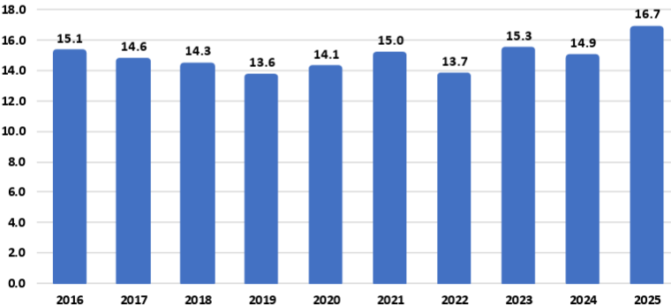
Source: USDA
For example:
The National Corn Growers Association (NCGA) is intensifying its call for action from Congress and the administration after the U.S. Department of Agriculture’s latest World Agriculture and Supply and Demand Estimates report projected a record 16.7-billion-bushel corn crop this year, further threatening the livelihood of farmers already facing record-low corn prices.
“Corn growers are already marketing their corn for extremely low corn prices, and this massive projected corn supply without market-based solutions to increasing corn demand is already causing corn prices to fall further,” said Illinois farmer and NCGA President Kenneth Hartman Jr. “Because we need markets fast for this supply, we are redoubling and intensifying our call for Congress to pass pending E15 legislation that will allow for year-round consumer access to higher blends of ethanol and for the Trump administration to quickly broker deals that will open new foreign markets for corn.”
Today’s WASDE report projects average corn yields of 188.8 bushels per acre for 2025, for an overall crop of 16.7 billion bushels. If the projections prove accurate, this year’s crop will be the largest on record by far: 1.4 billion bushels above the current production record set in 2023, a 9.1 percent increase.
An immediate boost to demand would be the passage of legislation authorizing year-round consumer access to 15 percent ethanol blend, or E15. This solution comes at no cost to consumers, requires no additional infrastructure developments and would generate demand for an additional 457 million bushels of corn, according to NCGA estimates.
NCGA is also pushing the administration to quickly broker additional deals with other countries and finalize details on deals already announced. For example, India, Vietnam and Kenya are all strategically important markets to U.S. corn growers.
Sen. Joni Ernst, R-Iowa, on July 31 introduced the Ethanol for America Act, a bill that aims to make it easier for Americans to fuel their vehicles with domestically produced E15. Companion legislation was introduced the following day by Rep. Adrian Smith, R-Neb.
The legislation would eliminate unnecessary barriers to E15 by requiring the U.S. EPA to finalize rulemaking from 2021 to make the E15 fuel label clearer and more consumer oriented. It would also confirm the compatibility of E15 with existing underground fuel storage and dispensing equipment.
Currently, fuel dispensers offering E15 must feature a label designed to alert customers to the appropriate and lawful use of the fuel. The proposed rule, issued in January 2021, co-proposes to either modify the E15 label or remove the label requirement entirely. The EPA opened a 90-day public comment period on the proposal but has failed to take final action on the rulemaking.
Following its introduction, the Senate bill, S. 2591, was referred to by the Senate Committee on Environment and Public Works. To date, Sens. Amy Klobuchar, D-Minn.; Deb Fischer, R-Neb.; Chuck Grassley, R-Iowa; Tammy Duckworth, D-Ill.; and Richard Durbin, D-Ill., have signed on to cosponsor the bill. The House bill, H.R. 4864, was referred to the House Committee on Energy and Commerce. Reps. Nikki Budzinski, D-Ill.; Dusty Johnson, R-S.D.; Tracey Mann, R-Kan.; Derek Schmidt, R-Kan.; Mike Flood, R-Neb.; Randy Feenstra, R-Iowa; and Brad Finstad, R-Minn., are cosponsoring the House bill.

Vietnam Opening Market to Ethanol
To boost ethanol imports from the U.S. tenfold to approximately 290 million gallons, the Vietnam Biofuel Association has proposed that the government swiftly implement a nationwide E10 biofuel gasoline program.
The Vietnam Biofuel Association recently submitted a document to the Domestic Market Management and Development Department (under the Ministry of Industry and Trade), addressing several issues related to the import tax on 99 percent ethanol used for biofuel blending, as well as the broader context of tariff negotiations and trade relations between Vietnam and the United States.
According to the association, the import tax on 99 percent ethanol - a type specifically used in biofuel gasoline blending - has continuously decreased from 15 percent to 12 percent, then 10 percent, and most recently to 5 percent. These reductions fall within the broader trade policy framework between Vietnam and the U.S.
Petrolimex and PVOIL, Vietnam’s two largest fuel distributors and retailers, launched the country’s first commercial trials of gasoline blended with 10 percent ethanol (E10) in three major cities last week. A total of 42 fuel stations in Hanoi, Ho Chi Minh City and Hai Phong began selling E10 RON95 gasoline as part of the trial that follows the Government of Vietnam’s recent announcement of a nationwide E10 mandate to begin in January.
“The U.S. Grains & BioProducts Council (USGBC) and its members and partners commend Petrolimex, PVOIL and the Government of Vietnam for advancing the use of fuel ethanol in Vietnam as a means to reduce harmful emissions, bolster fuel security and further stimulate rural economies,” said Ryan LeGrand, USGBC President and CEO. “This month’s rollout of E10 gasoline at retail stations is a massive step toward decarbonizing Vietnam’s transportation sector and a new potential partner for the U.S. ethanol industry and the American farmer.”
In 2018, Vietnam implemented an E5 mandate for its RON92 grade of gasoline, one of two gasoline grades widely used throughout the country. The Government of Vietnam’s decision to expand and migrate the country’s ethanol policy in 2026 to E10 and all grades of gasoline, including the more widely used RON95 grade, will help the Vietnamese fuel industry amplify the environmental and economic benefits of fuel ethanol use which augment Vietnam’s policy objectives.
Vietnam’s gasoline consumption surpassed 2.8 billion gallons in 2024, increasing 8.1 percent from 2023 consumption levels. A nationwide E10 mandate will create a total fuel ethanol demand of 280 to 300 million gallons per year, depending on gasoline demand.

USDA Land Value Report
The United States farm real estate value, a measurement of the value of all land and buildings on farms, averaged $4,350 per acre for 2025, up $180 per acre (4.3 percent) from 2024. The United States cropland value averaged $5,830 per acre, an increase of $260 per acre (4.7 percent) from the previous year. The United States pasture value averaged $1,920 per acre, an increase of $90 per acre (4.9 percent) from 2024.

Average Farm Real Estate Value (Dollars)
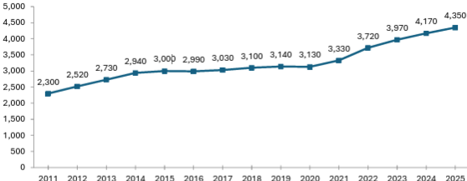
Source: USDA NASS

Farm Real Estate Value by State
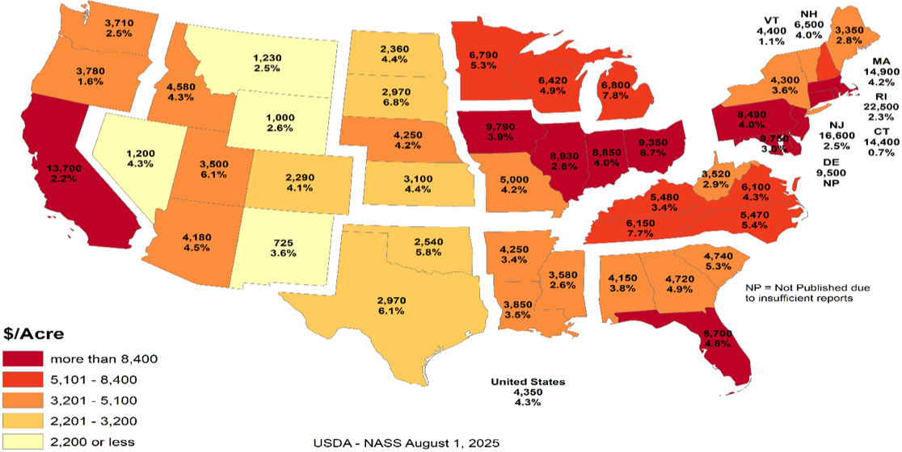
Like overall farm real estate values, average U.S. cropland values rose to record levels in 2025, reaching $5,830 per acre. This marks a 4.7 percent increase over 2024, nearly identical to the previous year’s growth but slower than the sharper increases earlier in the decade. In dollar terms, cropland values rose by $260 per acre year over year. Regional patterns remain consistent with broader farmland trends, with California and Northeastern states reporting the highest average cropland values. These are followed by much of the Midwest and Florida, the latter reflecting strong specialty crop production and ongoing residential development pressures. The top three states in percentage growth were Utah (9.7 percent), Michigan (8.2 percent) and Tennessee (7.8 percent). Notably, no states recorded a decline in cropland values.

Average Cropland Value (Dollars)
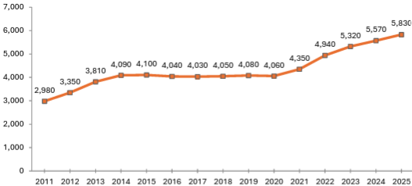
Source: USDA NASS

Cropland Value by State
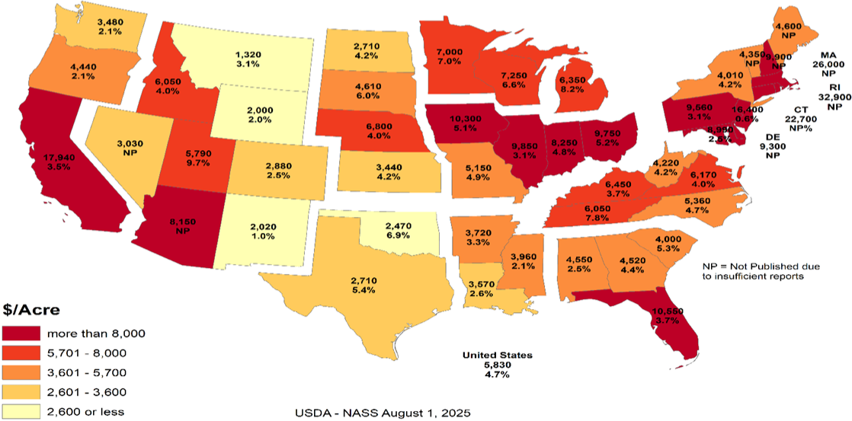
U.S. pastureland values continued their upward trend in 2025, rising to $1,920 per acre, a 5 percent increase over 2024. This growth is nearly in line with last year’s 5.2 percent gain but remains below the 6.7 percent increase in 2023 and the sharp 11 percent jump in 2022, which followed nearly a decade of stagnant values.
Unlike cropland and overall farm real estate, pastureland values are highest along the East Coast and mid-South, where development pressures, land scarcity and lifestyle demand contribute to elevated prices. In contrast, Western and Plains states report lower average values, partly due to lower land productivity and the prevalence of federally owned grazeable land accessed through grazing permits, which reduces market-based competition. In densely populated Eastern states, fragmentation of land and rising competition for open space (whether for grazing, recreation or rural living) continue to drive up per-acre costs for the limited private pastureland available.

Average Pasture Value (Dollars)
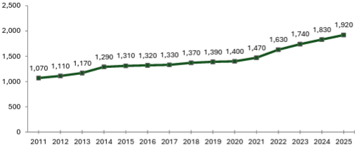
Source: USDA NASS

Pasture Value by State
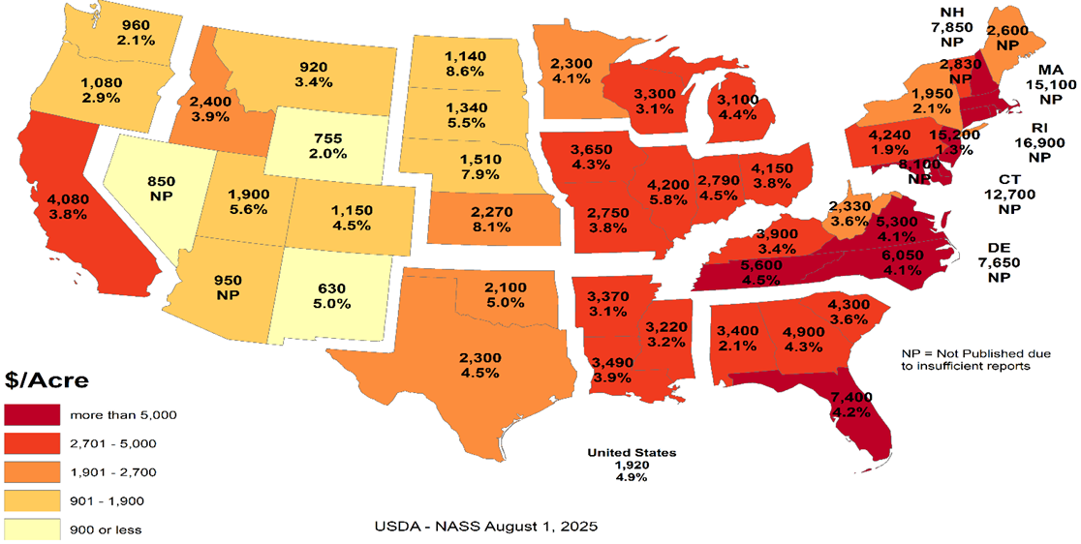

Cash Rents
American Farm Bureau summarized the USDA NASS cash rent survey.
NASS also released data on cash rents, which tend to lag changes in land values and commodity prices due to early-season lease negotiations. While the reported figures reflect past agreements, they often serve as important benchmarks for future producer-landlord negotiations, especially in areas with variable rent structures. Average U.S. cropland rent increased to $161 per acre in 2025, a modest 0.6 percent rise over 2024 — just $1 per acre. Irrigated cropland rents declined by 0.4 percent to $244 per acre, while non-irrigated rents rose 0.7 percent to $147 per acre. Pastureland cash rents remained unchanged at $15.50 per acre.
Despite minimal national movement, pressures on open land for solar development, suburban expansion and recreation continue to support rental rate growth in select areas, particularly where demand for working land is layered with lifestyle or energy investment interest. Increased telework continues to pull buyers and lessees into rural areas, intensifying local competition for land in certain high-amenity or fast-growing regions.
While earlier rent increases were tied closely to the 2021–2022 commodity price boom, today’s changes are more uneven, shaped by regional water constraints and shifting cropping patterns. In some areas, recent federal disaster assistance may have tempered pressure to renegotiate downward, even as commodity prices weaken and input costs remain high.

Cropland Cash Rent Value by State (Percent Change)
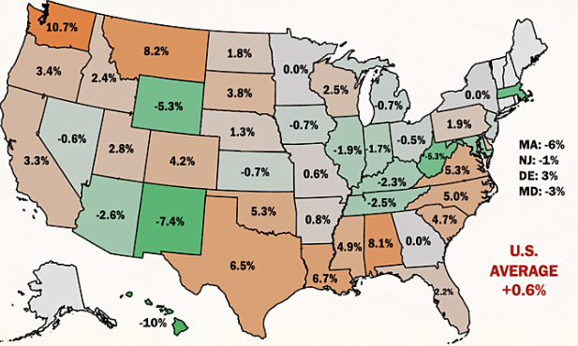
Source: American Farm Bureau, USDA NASS
Washington and Montana led the country in cropland cash rent growth, up 10.7 percent and 8.2 percent, respectively, followed by Alabama at 8.1 percent. Meanwhile, cropland rents in Hawaii, New Mexico, Wyoming, West Virginia and Massachusetts declined by more than 5 percent, likely due to a mix of stabilized drought conditions, changing land use priorities and rebalancing after years of sharp growth.
By value, the most expensive cropland rents remain in states with high-value specialty crops, such as California ($346/acre), Arizona ($334/acre) and Hawaii ($295/acre), often driven by contracts tied to irrigation infrastructure and water rights. Iowa, Illinois, Indiana and Washington round out the next tier of high-rent states, reflecting both row crop concentration and specialty crop presence. Water access and cost continue to be major drivers of both land value and rental rates across the Western U.S.
Margins for producers who rely heavily on rented land remain precarious, especially as revenue potentially slips while fixed costs (including rents) remain elevated or inflexible. Beginning farmers and those without land equity are especially exposed, facing steep barriers to accessing operating credit. In a year where net farm income is forecasted to decline without ad hoc support, even modest increases in rental rates can have outsized financial consequences.

Conclusion
Rural land values are experiencing a price bubble. In many of the Corn Belt states the cropland value continues to increase while the cash rent decreases. The values represent the impact of government land-based farm programs and ad hoc payment that could go to landowners. The government incentives to buy land have diminished the link between land values and real agricultural value. The result is farmers who rent land are increasingly in financial distress. As farmers exit the market, the disconnect between the land prices and cash rents will increase.
What the government gives it can take away. The Democrat party can win without the farm vote. Their messaging is trending away from “preserving family farmers” to “bashing Big Ag.” If rural land prices start declining, the floor is real agricultural value. For example, Illinois cash rent for cropland is $264 per acre. Farmdoc crop budget indicates that if a cash rent farmer needs $100 profit per acre to survive, the cash rent should be approximately $133 per acre or a decrease of approximately half. Assuming a 5 percent rate of return, the real agricultural value for cropland in Illinois is $2,660 per acre versus $9,850 per acre.
The other concern is that many of the new land buyers are investors. The investors are helping to drive land prices higher. When land values decrease, will the investors sit tight or take a profit? The investors do not have the same emotional attachment to the land. Farmers who want to own their own land act as a “put” under the land market. The good news is the farmers currently have low debt levels. This means the farmers have access to cash to buy land. The unknown is if the farmers are making a good investment or trying to catch a falling knife.

Cropland Cash Rent Value by State
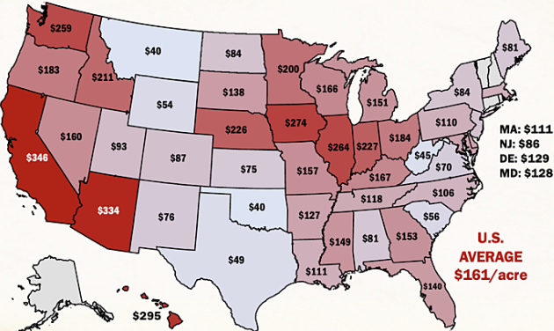
Source: American Farm Bureau, USDA NASS

Farmer Sediment
The Purdue University-CME Group Ag Economy Barometer index declined for the second month in a row. The July index fell 11 points below June’s reading and was fueled by U.S. farmers’ weaker perceptions regarding both current conditions and their expectations for the future. The July Current Conditions Index fell 17 points while the Future Expectations Index declined 7 points, both compared to a month earlier. Weaker income prospects in 2025 were largely responsible for farmers’ weaker appraisal of current conditions. Although all three principal farmer sentiment indices were lower in July than a month earlier, producer sentiment remains much more positive than at this time last year, with nearly three-quarters of July’s survey respondents reporting that the U.S. is headed “in the right direction.” The July barometer survey took place from July 7-11, 2025.
Concerns about weak income prospects in 2025 were evident in the July survey as the Farm Financial Performance Index fell 14 points compared to a month earlier. This month’s decline left the index at a reading of 90, indicating that more farmers expect weaker rather than stronger income in 2025 compared to 2024. Weakening crop prices are eroding income prospects. For example, in the Eastern Corn Belt, bids for fall harvest delivery of corn and soybeans were 7 percent and 3 percent lower during the July survey week, respectively, than just 4 weeks earlier. In turn, the decline in farmers’ income prospects helped push the Farm Capital Investment Index down 7 points in July to a reading of 53.

Farm Financial Performance Index
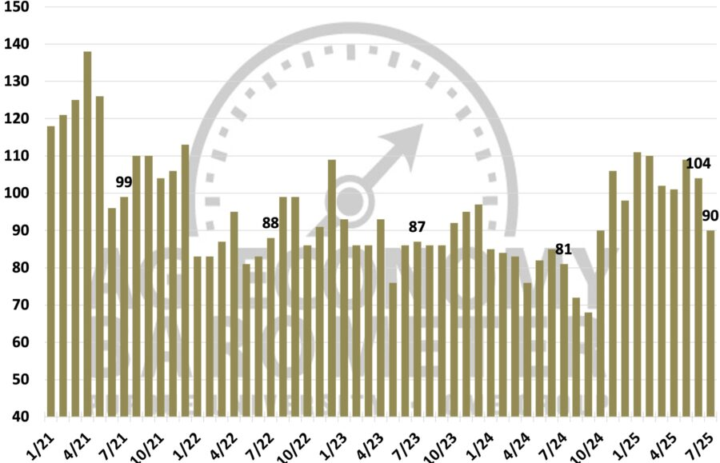
Source: Purdue/CME Group Ag Economy Barometer
Unsurprisingly, a weaker income outlook led to a softer outlook for farmland values in the upcoming year. The Short-Term Farmland Value Expectations Index dipped 5 points below a month earlier. This month’s reading of 115 also left the index 3 points lower than a year earlier and 10 points below two years ago. The farmland index’s weakness was attributable to a small shift among respondents away from expecting values to rise to looking for weakening values in the upcoming year, while the percentage expecting values to hold steady rose just one point to 57 percent. With farmland leasing discussions for next year underway between farmers and landowners, this month’s survey included a question regarding crop producers’ expectations for farmland cash rental rates in 2026. Despite weakening crop income prospects, nearly three-fourths (73 percent) of respondents said they expect cash rental rates in 2026 to remain about the same, with just 11 percent of crop producers indicating they expect rental rates to decline.
One supporting factor for both farmland values and farmland cash rental rates could be producers’ expectations regarding the farm income safety net provided by U.S. farm programs. In this month’s survey, 31 percent of respondents said they expect the safety net in the 2025 Farm Bill to be stronger than in the previous Farm Bill.
U.S. farmers in July were somewhat more optimistic about future agricultural trade prospects than a month earlier. This month, 43 percent of respondents said they expect agricultural exports to increase in the upcoming five years, up from 41 percent a month earlier. Fewer producers said they are looking for exports to decline, dropping to 13 percent of respondents, down from 16 percent who felt that way in June. In a related question, 64 percent of this month’s survey respondents said they think it likely that new foreign export markets will open to American agricultural goods in the next five years. To further gauge U.S. farmers’ outlook regarding trade and policy, this month’s survey included the following question: “Would you say things in the United States today are generally headed in the right direction or on the wrong track?” Seventy-four percent of respondents said the U.S. is headed in the “right direction.”
U.S. farmers’ sentiment declined in July as weaker farm income prospects dimmed producers’ view of current conditions and their future expectations. Despite a weaker crop income outlook, just 11 percent of crop producers said they expect farmland cash rental rates to decline, with a majority reporting that they expect rental rates to stay about the same. Helping to support producers’ farmland value and rental rate outlook is farmers’ expectation for a stronger farm income safety net, with nearly one-third (31 percent) of U.S. producers saying they expect the 2025 Farm Bill to provide a stronger safety net than the previous Farm Bill. Producers in July were somewhat more optimistic about U.S. agricultural trade prospects than in June, while nearly three-fourths (74 percent) of U.S. farmers responding to the survey reported that they feel that things in the U.S. are headed “in the right direction.”

Bunge Buys IFF Crush Division
As part of its second quarter results disclosure, International Flavors & Fragrances Inc. announced that it has entered into a definitive agreement to divest its soybean crush, concentrates, and lecithin business to Bunge Global S.A. The transaction includes operations that generated approximately $240 million in revenue in 2024 and employs around 250 people globally. The sale aligns with IFF’s strategy to strengthen its portfolio and supports the ongoing evaluation of strategic alternatives for its Food Ingredients segment, with a focus on maximizing shareholder value.

Greenhouse Gas Phase 3 Standards do not Apply to Human Health
The industry has an aftertreatment system for EPA's 2007 and 2010 Heavy-Duty Highway Engines and Vehicle emissions reduction regulations, which set standards for not only NOx but also particulate matter (PM). It also mandated the use of advanced emission control technologies like selective catalytic reduction (SCR) and diesel particulate filters. "Completely separate," said North American Council for Freight Efficiency Executive Director Mike Roeth. "Aftertreatment is not a direct GHG solution. We tend to call NOx and PM pollutant emissions, and they are directly attached to human health; breathing in these in the air... Carbon/GHG is different in that it affects climate, encouraging our more frequent and harsher weather events causing other health concerns."
Daimler Truck North America (DTNA) noted in a statement to Commercial Carrier Journal (CCJ) that the proposal does not modify EPA's existing requirements for criteria pollutants, including NOx and PM. NOx and PM standards remain in place, and they continue to be enforced independently of any changes to GHG regulations. "Selective Catalytic Reduction (SCR) systems, Diesel Exhaust Fluid (DEF), and aftertreatment technologies are essential components designed to reduce nitrogen oxides (NOx) regulated under the EPA's Clean Air Act," added Paccar companies Kenworth and Peterbilt. "The current aftertreatment systems related to NOx are still required to meet EPA and CARB standards and are independent of greenhouse gas (GHG) specific mandates."
Covered in the Endangerment Finding is nitrous oxide (N2O). NOx is shorthand for nitric oxide (NO) and nitrogen dioxide (NO2), the nitrogen oxides most relevant for air pollution. NOx itself is not considered a greenhouse gas; rather it plays a role in the formation of ozone, a naturally occurring greenhouse gas. Thus, NOx is not a greenhouse gas and the aftertreatment system, including DEF, would not be affected by this pending regulatory change.
However, EPA Administrator Lee Zeldin said in March his office intends to revisit portions of the Biden-era Clean Trucks Plan, which includes the 2022 Heavy-Duty NOx rule – a standard that includes new, more stringent emissions standards that cover a wider range of heavy-duty engine operating conditions and requires these more stringent emissions standards to be met for a longer period of time.

DEF Guidance Clarification
Starting in the early 2010s, regulations required all new on-road diesel vehicles, tractors, trucks, buses, ships, locomotives, gas turbines and construction equipment, to install additional technology to reduce nitrogen oxide emissions, a byproduct of diesel. Almost all commercial diesel transportation and equipment today has Selective Catalytic Reduction (SCR) technology that runs on DEF.
According to an EPA release, "EPA issued clear guidance urging engine and equipment manufacturers to revise DEF system software in existing vehicles and equipment to prevent these sudden shutdowns, giving operators more time to repair faults without impacting productivity or safety."
The EPA provided a chart showing derate timing for heavy duty trucks will be extended from a 5-mph limitation after just four hours' worth of a system fault to a three-stage derate:
- 15 percent torque reduction at 650 miles / 10 hours
- 30 percent torque reduction then at 4,200 miles / 80 hours
- and a final-stage derate to 25 mph at 8,400 miles / 160 hours
"In addition to providing certainty to manufacturers about how EPA wants this issue resolved, the agency is not requiring separate approvals beyond that provided in EPA’s guidance," the release said. "This ensures that bureaucratic steps do not delay manufacturers’ ability to put solutions into the field.”
Before the new EPA DEF guidance, a farmer had four hours before the vehicle or equipment stopped operating, leaving the farmer stranded. EPA’s new guidance to engine manufacturers will reduce derating, an automatic trigger forcing the engine to operate at a reduced capacity far below its capability and increase the amount of time operators must secure DEF and refuel.
Previously, farmers and truckers faced rapid engine slowdown to 5 mph within just four hours of a sensor alert. Under EPA’s new guidance for heavy-duty trucks, for example, after a fault is detected, only a warning light appears for 650 miles or 10 hours. Most significantly, there is no performance impact for at least one workday. Then, the engine only mildly derates by 15 percent, but this does not limit speed, allowing trucks to operate normally for up to 4,200 miles or two work weeks. Only after about four work weeks does speed drop to 25 mph until repairs are made. Most operators are expected to fix issues well before reaching this limit. Moving forward for farmers, non-road equipment will not experience an impact for the first 36 hours.
The ruling represents a major step up from the status quo by giving operators significantly more time to address faults before experiencing severe engine or speed limitations, which will improve their ability to complete daily operations and reduce downtime.
The revised DEF guidance is estimated to reduce farming expenses by $727 million annually. With fewer disruptions, reduced costs for emergency towing, repairs, rentals, DEF deliveries and inventories, producers will have greater operational and financial control.

Truck Manufacturers Sue CARB/California
Four of America’s top truck makers have officially filed a lawsuit in the U.S. District Court for the Eastern District of California challenging the Clean Truck Partnership (CTP) agreement signed with the California Air Resources Board in 2023. CARB has argued since the Congressional rollback of its Advanced Clean Trucks and Omnibus Low-NOx rules earlier this summer that despite the federal disapproval of the regulations, the CTP is still binding.
Cummins, Daimler Trucks North America, Hino, Isuzu, then-Navistar, Paccar, the Truck and Engine Manufacturers Association, and Volvo Group North America in July 2023 were among 11 signers of the CTP, an agreement with CARB that pledged truck and engine manufacturers will meet California’s vehicle standards and required the sale and adoption of zero-emission vehicle (ZEV) technology.
The OEMs said in the lawsuit that despite the Congressional Review Acts passed this year preempting California’s emissions standards, the state “continues to demand compliance with its heavy-duty emissions standards, and it has threatened OEMs that design, develop, manufacture and sell heavy-duty vehicles and engines ... with civil sanctions and unfavorable regulatory treatment if the OEMs refuse to comply with the state’s unlawful standards, while also taking measures to insulate itself from lawful challenges to those standards.”
Senior Clean Vehicles Advocate for the Natural Resources Defense Council Guillermo Ortiz called the lawsuit, "a cynical reversal of course. These companies helped negotiate the Clean Truck Partnership to secure regulatory certainty. Now they’re trying to dismantle the very deal they shaped -- injecting instability into a market they claim to lead," he said. "This is bad faith, plain and simple, and it raises questions about whether these manufacturers are serious about their ability to deliver clean trucks to the global stage."
The OEMs said the U.S. Department of Justice has sent them Cease & Desist letters stating that California’s enforcement of its regulations “is contrary to federal law” and directed the truck makers “to immediately cease and desist compliance with California’s preempted and unlawful mandates.”
This has left the OEMs “caught in the crossfire,” they said, as “California demands that OEMs follow preempted laws; the United States maintains such laws are illegal and orders OEMs to disregard them. This situation is not tenable.”
As such, the lawsuit aims to clarify the OEMs’ legal obligations under federal and state law and to block California from enforcing regulations that are preempted by federal law. Given the inconsistencies between federal and California regulatory requirements for emissions, truck and engine makers and their trade associations in 2023 petitioned CARB for relief from the state’s “infeasible regulatory requirements,” which resulted in the CTP, the lawsuit added. Now, according to the OEMs, “California seeks to use the Clean Truck Partnership, which was intended to harmonize compliance with state and federal law, to compel an entire industry to follow California emissions standards that are now in conflict with federal law, and which have been expressly preempted by federal law.” They added that the state is disregarding the CTP’s “plain language,” which “states that manufacturers are obligated to follow CARB’s emissions regulations ‘regardless of the outcome of any litigation challenging … those regulations, or CARB’s overall authority to implement those regulations,’ not federal legislative action taken to invalidate them.”
The regulatory back-and-forth between the federal government and California/CARB has put OEMs “in an impossible position,” they said in the lawsuit. “As a result, the OEMs are subject to two sovereigns whose regulatory requirements are irreconcilable and who are openly hostile to one another. Each wields a hammer to enforce its will on industry, leaving OEMs -- who simply seek to sell heavy-duty trucks in compliance with the law -- unable to plan with the necessary certainty and clarity where their products need to be certified for sale and by which regulatory authority.”
California, citing the CTP, has contended that in order for OEMs to legally sell trucks in the state, they must obtain certification from CARB. Yet the OEMs said this process “takes months,” adding that they “need to know within a matter of weeks whether they must obtain a model year 2026 certification from CARB in order to lawfully sell their products in California and other opt-in states, which together represent approximately 25 percent of the national market for new vehicle registrations for heavy-duty vehicles.”
In filing the lawsuit, the truck makers said they are looking for “declaratory and injunctive relief with the goal of clarifying and establishing the regulatory obligations that they must follow to lawfully offer products for sale in California and the various opt-in states, and to prevent California officials from violating their constitutional rights,” adding that “an expeditious decision is essential.”
The OEMs’ lawsuit joins another suit brought by the Western States Trucking Association that challenged CARB’s authority to enforce the CTP following the federal preemption of the regulations.

Ambassador Jamieson Greer: Why We Remade the Global Order
The following op-ed provides the foreign policy vision of the Trump Administration. On the 200-day mark of the second Trump administration, United States Trade Representative Jamieson Greer published an op-ed in The New York Times explaining how President Trump’s trade policy is remaking the international economic order to reduce our trade deficit and deliver lasting benefits for American workers and industries.
The full text of the op-ed is below:
It must be an unwritten rule that international economic orders emerge at stately hotels. In 1944, as World War II raged, Allied representatives gathered at a picturesque New Hampshire resort named Bretton Woods to discuss how to establish a postwar economic order to restore the sensible flow of trade in a fractured world.
Although the resulting Bretton Woods system ended in 1976, its legacy lives on. Our current, nameless global order, which is dominated by the World Trade Organization and is notionally designed to pursue economic efficiency and regulate the trade policies of its 166 member countries, is untenable and unsustainable. The United States has paid for the system with the loss of industrial jobs and economic security, other countries have been unable to make needed reforms, and the biggest winner has been China, with its state-owned enterprises and five-year plans. Unsurprisingly, the past decade has seen significant international and bipartisan American frustration at the system’s failure to adapt to meet the essential interests of sovereign nations.
Now, reform is at hand. Last week at his Turnberry resort on the Scottish coast, President Trump and the European Commission president, Ursula von der Leyen, concluded a historic agreement — one that is fair, balanced and oriented toward serving concrete national interests rather than vague aspirations of multilateral institutions. Indeed, by using a mix of tariffs and deals for foreign market access and investment, the United States has laid the foundation for a new global trading order.
The previous system rejected tariffs as a legitimate tool of public policy, meaning that the United States sacrificed tariff protection for critical manufacturing and other sectors. Over the past three decades, the United States slashed barriers to our market to allow vast inflows of foreign goods, services, labor and capital. At the same time, other countries kept their markets closed to our goods and deployed a suite of policies — such as subsidies, wage suppression, lax labor and environmental standards, regulatory distortions and currency manipulation — to artificially boost exports to the United States. This approach made the United States and a handful of other economies the consumers of last resort for countries pursuing beggar-thy-neighbor economic policies.
Our trading partners were adept at this game, and elites on Wall Street and in Washington were all too happy to cash in on the global arbitrage by moving production abroad. The net result? The bulk of global manufacturing shifted to jurisdictions such as China, Vietnam and Mexico where companies could exploit vulnerable workers or benefit from expansive state support while the United States ran up what in absolute terms is the highest trade deficit in the history of the world. This led to extensive and well-documented losses in U.S. industrial capacity and employment as well as reliance on our adversaries for critical supply chains.
We subordinated our country’s economic and national security imperatives to a lowest common denominator of global consensus. This approach harmed American workers, their families and communities by undermining a manufacturing sector that creates high-wage jobs, fosters innovation and catalyzes investment across the economy.
What began at Bretton Woods as a necessary effort to rebuild a global trade system shattered by war evolved, over nine rounds of trade negotiations, into something unrecognizable. The measured guidelines for commerce developed in the Kennedy and Tokyo Rounds gave way to our recent experiment in global hyper-integration, embodied in the Uruguay Round, which concluded in 1994 and established the W.T.O.
We are now witnessing the Trump Round. On April 2, President Trump announced tariffs to address the national emergency posed by the trade deficit. The intense bilateral negotiations that followed were held in diverse locations across the world: Washington, Geneva, Jeju Island, Paris, London, Stockholm and, of course, Turnberry. Our trading partners had never before shown such interest in opening their markets to the United States, aligning on matters of economic and national security, and rebalancing trade in a more sustainable direction. In a few short months, the United States secured more foreign market access than it had in years of fruitless W.T.O negotiations.
Reversing decades of harmful policy that weakened our manufacturing capacity and work force will take time and coordinated effort across the public and private sectors. But keeping the status quo would only accelerate the dangerous trajectory of deindustrialization. We require a generational project to re-industrialize America, and time is short.
When I joined a critical mass of my fellow trade ministers in June at a meeting of the Organization for Economic Cooperation and Development in Paris, I was struck by how many voiced serious concerns about the danger of macroeconomic imbalances, the threat of nonmarket practices and the sclerotic state of the global trading system — the same issues President Trump has raised for years and now taken emergency action to address. What was long dismissed as heresy by the free-trade fundamentalists in Brussels, Geneva and Washington is now becoming conventional wisdom.
In announcing the U.S.-European Union deal last week, President von der Leyen echoed the call to refashion global trade to adapt to economic and political realities. She explained to reporters that the trans-Atlantic economic relationship needed “rebalancing” to ensure that it could be “more sustainable.” Such recognition is reinforced by additional deals with Britain, Cambodia, Indonesia, Japan, Malaysia, Pakistan, the Philippines, South Korea, Thailand and Vietnam, which make up almost 40 percent of U.S. trade, according to my office’s figures. Other countries with large trade surpluses with the United States are subject to generally higher tariffs. The new economic order, solidified at Turnberry, is emerging in real time.
The results are astounding. Every year for 40 years, the Office of the U.S. Trade Representative has produced a detailed report called the National Trade Estimate chronicling various barriers faced by U.S. companies, including high tariffs, requirements to produce goods in the countries where the companies want to do business, and restrictions on agricultural products contrary to scientific consensus. In the past, the only significant way the United States could remove these barriers (if at all) was by giving away the tariffs defending our manufacturing sector. President Trump has flipped the script on this: Now, we are systematically eliminating these barriers abroad while ensuring sufficient tariff protection at home.
Indonesia is lowering 99.3 percent of its tariffs on imports from the United States and eliminating a slew of longstanding non-tariff barriers, while accepting a 19 percent tariff on exports to the United States. South Korea is accepting U.S. auto standards along with a 15 percent tariff. Vietnam pledged to lower all of its tariffs and barriers in exchange for a 20 percent rate. Most countries we are negotiating with have also agreed to cooperate on economic security to ensure the safety and reliability of our critical supply chains.
Countries are also committing to upgrade and better enforce their labor standards, tackling arbitrages that have put American workers and producers at a disadvantage. Multiple countries will join the United States (along with the E.U., Mexico and Canada) in banning the importation of goods made with forced labor. Eliminating global slavery was a longstanding goal of advocates and policymakers, but it was the leverage of President Trump’s tariffs that finally made it possible to unlock meaningful progress.
Similarly, countries are agreeing to improve resource efficiency and enforcement of environmental laws, including in the most problematic sectors, such as illegal logging, illegal fishing and the illegal wildlife trade. The international trade system should not force Americans to compete with those who use our responsible capitalism against us as a competitive advantage.
Importantly, these commitments are actionable, and the United States will enforce them. Rather than the drawn-out dispute settlement process favored by the old guard of trade bureaucrats, the new U.S. approach is to closely monitor implementation of the deals and swiftly reimpose a higher tariff rate for noncompliance if needed. President Trump uniquely recognizes that the privilege of selling into the world’s most lucrative consumer market is a mighty carrot. And a tariff is a formidable stick.
At the World Trade Organization, enacting changes to trade rules requires total consensus among nations. In fact, the last attempt at serious reform, known as the Doha Round, failed because protectionist nations refused to take down their trade barriers to the United States. Moreover, our adversaries relish blocking reform. They prefer a status quo that feeds an exploding U.S. trade deficit, sapping this nation of the industrial might that made it, and keeps it, a superpower.
But the rules of international trade cannot be a suicide pact. By imposing tariffs to rebalance the trade deficit and negotiating significant reforms that form the basis of a new international system, the United States has shown bold leadership to address what policymakers long considered intractable problems.
Many of these deals also come with significant investment commitments into U.S. productive capacity, such as $600 billion in the case of the European Union and $350 billion by South Korea. These investments — 10 times larger than the inflation-adjusted value of the Marshall Plan that rebuilt Europe after World War II — will accelerate U.S. reindustrialization. South Korea will help reinvigorate the American shipbuilding industry, which has atrophied in the face of nonmarket competition. These types of investments are on top of purchase commitments that cumulatively account for almost $1 trillion of American energy, agriculture, defense and industrial products. This demand for American goods and ready access to capital will allow American manufacturing to reassert leadership across strategic sectors where we have fallen behind.
Skeptics point out that tariffs, although once a fixture of American economic policy, have not been used this extensively for generations. But we now have data showing that the failure to use tariffs or similar protections created an economy that was heavy on finance and consulting fees and low on the lasting wealth and security that come from making things. Even among those who agree with that diagnosis, some say the president’s remedy is too strong or was administered too hastily, or that the tariffs will be too disruptive in the short term. This is not the time to debate how many angels can dance on the head of a pin. This is an emergency. We know what the problem is and we know how to address it. There is no time to waste.
President Trump has already shown that he can implement tariffs and other economic tools to reshape supply chains and reinvigorate manufacturing. When he deployed sweeping tariffs in his first term, not only did the sky not fall as pundits predicted, but inflation actually went down. And now that he is imposing tariffs even more broadly, inflation remains in check. A long-term problem won’t be fixed overnight, and the process may not always be smooth, but the situation demands strong and resolute action to strengthen the U.S. industrial base.
It took over 50 years from that first meeting at Bretton Woods until the creation of the W.T.O. It has been 30 years since. Fewer than 130 days from the beginning of the Trump Round, the Turnberry system is by no means complete, but its construction is well underway.

Stagflation Discussion
Stagflation talk has taken center stage. It should be remembered that stagflation in the 1970s was driven by crude oil prices increasing from $3.56 per barrel in August 1973 to $10.11 per barrel in January 1974 to $14.85 per barrel in January 1979 to $39.50 per barrel in May 1980. In less than seven years crude oil price increased by over 1,100 percent. By comparison, the current crude oil price is approximately half the May 2022 price. With almost every country expanding energy production, lower energy prices could occur.
According to the prolonged price decrease in crude oil and natural gas, inflation numbers will be below macro-economic models. This is because energy is incredibly important as it impacts inflation numbers directly, such as fuel and as a feedstock in petrochemicals, and indirectly, such as an increased cost that a manufacturer and business must recoup. Energy costs impact input prices for production, and every other stage required to reach the consumer with each cost increase being pushed to the next level. The cumulative impact of higher energy prices on the consumer tends to be understated by macro-economic models.
One inflationary outcome from lower energy prices is discretionary income increasing, which allows for more spending. The other outcome is the producer price index will show a decline with retail sales prices staying firm and retailers performing better than if it was still a higher energy cost environment. Any economic downturn will force retailers to lower prices to move products.
The inflationary impact of the massive increase in the money supply has worked its way through the economy, resulting in a natural slowdown. It is difficult to have runaway inflation with lower energy prices, and a weak housing market.
During the last trade war, the rate of inflation decreased. It is not a forgone conclusion that the rate of inflation is going to increase. The consumer price index increased a seasonally adjusted 0.2 percent for the month and 2.7 percent on a 12-month basis, the Bureau of Labor Statistics reported. That compared with the respective Dow Jones estimates for 0.2 percent and 2.8 percent.
Excluding food and energy, the core CPI increased 0.3 percent for the month and 3.1 percent from a year ago, compared with the forecasts for 0.3 percent and 3 percent. Federal Reserve officials generally consider core inflation to be a better reading for longer-term trends. The monthly core rate was the biggest increase since January while the annual rate was the highest since February.
Tariff-sensitive new vehicle prices also were unchanged. For now, automakers are choosing to keep market share.
A 0.2 percent increase in shelter costs drove much of the rise in the index, while food prices were flat and energy fell 1.1 percent, the BLS said. U.S. housing market now 508,715 more home sellers than homebuyers. With the current housing market experiencing pain, it is easier to envision lower prices not higher prices.

U.S. Consumer Price Index (Annual Change)
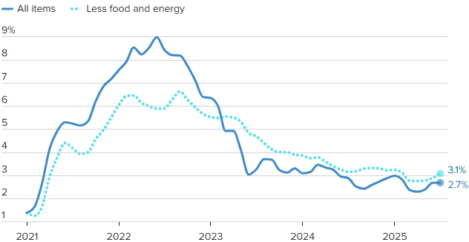
Crude Oil $120 per barrel
Source: BLS, CNBC

Estimated Number of Homebuyers and Sellers
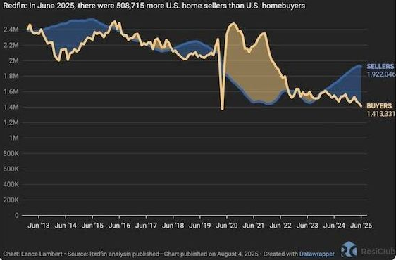

Mid-America Manufacturing Slumps for July
After six straight months of above growth neutral readings, the Creighton University Mid-America Business Conditions Index, a leading economic indicator for the nine-state region stretching from Minnesota to Arkansas, sank below 50.0 growth neutral threshold for July.

Overall Index
The Business Conditions Index, which uses the identical methodology as the national Institute for Supply Management (ISM) and ranges between 0 and 100 with 50.0 representing growth neutral, declined to 49.4 for July from 50.7 in June.
“Creighton’s latest survey continues to reflect job losses across the region, accompanied by elevated wholesale inflation,” said Ernie Goss, PhD, Director of Creighton University’s Economic Forecasting Group and the Jack A. MacAllister Chair in Regional Economics in the Heider College of Business. “Supply managers expressed growing concern that rising tariffs could further accelerate inflationary pressures. Despite these concerns, only 6.7 percent of surveyed supply managers reported shifting purchases from international to domestic suppliers in response to the tariffs.”

Employment
The July employment index fell to 45.4 from 49.4 in June, marking the fourth consecutive month below the growth-neutral threshold of 50. This sustained weakness reflects ongoing labor market challenges in the regional manufacturing sector.
“The Creighton survey has now recorded six straight months of job losses across the nine-state Mid-America region,” said Goss. “While employment rose in the first quarter—driven by increased production ahead of anticipated tariff impacts—the last four months have signaled a return to regional manufacturing job declines,” said Goss.
U.S. Bureau of Labor Statistics data show that the region shed 12,900 (-0.9 percent) manufacturing jobs over the past 12 months. The U.S. lost 89,000 (-0.7 percent) manufacturing jobs over the same time period.
Comments from Supply Managers in July:
- “Most of the suppliers I work with are dropping their production down to four-day work weeks. Nothing like a 20 percent cut in pay.”
- “I believe that the President's tariff changes are going to help our country to be better trading partners. It will take a bit of time for it all to shake out though.”
- “No changes to international purchases until a final tariff rate is in place. Certain products have been put on hold.”
- “We are not accepting pricing increases and have any tariffs added as a surcharge, so they are easy to remove.”
- “Long-term contracts have been key to holding pricing steady. Where there are extreme cost pressures with suppliers, collaboration on a resolution is the method of choice, while rare.”
- “While the Trump administration is doing everything possible to bring the economy back to its former glory, the democrats continue their seditious acts to block any attempts at dismantling their previous criminal maneuvers to destroy this great country! A reckoning is coming.”

Wholesale Prices
The July price gauge climbed to 69.7 from 67.9 in June. “The regional inflation yardstick has moved into a range indicating that inflationary pressures are moving higher at the wholesale level. However, due to a slowing regional and U.S. economies, I expect the Federal Reserve to cut interest rates at its September 16-17 meetings,” said Goss.
On average, supply managers expect tariffs to push input prices up by 7.8 percent over the next 12 months. This is up from 7.5 percent recorded in June.

Confidence
Looking ahead at the next six months, economic optimism, as captured by the July Business Confidence Index, dropped to 42.6 from June’s 50.0. “Concerns regarding tariffs and slowing new orders pushed supply managers’ expectations lower. Only one in six supply managers expect rising economic conditions for their firm over the next six months,” said Goss.

Inventories
The regional inventory index, reflecting levels of raw materials and supplies, increased to 49.1 in July from June’s 46.9. “Rapid expansions in inventories in the first quarter are now being offset by monthly pullbacks in buildups,” said Goss.

Trade
Recent uncertainty regarding tariffs and trade restrictions pushed new export orders lower for the last four months. New export orders slumped to 38.3 from 43.4 in June. As a result of record imports for the first two months of 2025, supply managers pulled back on purchasing from abroad in the last five months. The July import index increased to a still weak reading of 36.3 from 30.0 in June.
Supply managers were asked about their firm’s reactions to tariffs and threats of tariffs. Only 6.7 percent of manufacturing supply managers reported switching from international suppliers to domestic suppliers. More than one-third, or 67.0 percent, reported making no changes of suppliers due to tariffs. The remaining 26.3 percent indicated that their firms had switched from one international supplier to another international input supplier.
According to U.S. International Trade Administration (ITA) data, the regional economy exported $38.9 billion in manufactured goods for the first five months of 2025, compared to $40.8 billion for the same period in 2024, for a 4.7 percent decline. In terms of export gainers, North Dakota registered the top percentage gain with a 42.6 percent addition, and South Dakota recorded the largest percentage loss with a 19.9 percent reduction in the export of manufactured goods.

Other Survey Components of the July Business Conditions Inde
New orders dropped to 45.5 from 52.4 in June; the production or sales index increased slightly to 49.0 from 48.5 in June; and the speed of deliveries of raw materials and supplies rose to 57.8 from June’s 56.5. Higher readings indicate slower deliveries and/or rising supply chain disruptions or delays.

Arkansas
The state’s July Business Conditions Index fell to 43.0 from 48.2 in June. Components from the July survey of supply managers were new orders at 43.7, production or sales at 47.0; delivery lead time at 53.1; inventories at 39.5; and employment at 31.8. According to ITA data, the Arkansas manufacturing sector exported $2.3 billion in goods for the first five months of 2025, compared to $2.4 billion for the same period in 2024, for a 5.6 percent decline.

Iowa
The state’s Business Conditions Index for July declined to 43.7 from 48.0 in June. Components of the overall July index were new orders at 43.9; production or sales at 47.3; delivery lead time at 53.6; employment at 33.2; and inventories at 40.6. According to ITA data, the Iowa manufacturing sector exported $6.2 billion in goods for the first five months of 2025, compared to $6.9 billion for the same period in 2024, for a 10.3 percent decline.

Kansas
The Kansas Business Conditions Index for July increased to 51.1 from 49.9 in June. Components of the leading economic indicators from the monthly survey of supply managers for July were new orders at 45.5; production or sales at 50.3; delivery lead time at 58.6; employment at 47.7; and inventories at 58.6. According to ITA data, the Kansas manufacturing sector exported $5.0 billion in goods for the first five months of 2025, compared to $5.2 billion for the same period in 2024, for a 3.5 percent decline.

Minnesota
The July Business Conditions Index for Minnesota dropped to 49.3 from 52.8 in June. Components of the overall July index were new orders at 45.1; production or sales at 49.8; delivery lead time at 57.5; inventories at 50.2; and employment at 44.3. According to ITA data, the Minnesota manufacturing sector exported $9.5 billion in goods for the first five months of 2025, compared to $10.7 billion for the same period in 2024, for an 11.4 percent decline.

Missouri
The state’s July Business Conditions Index rose to 51.8 from 50.8 in June. Components of the overall index from the survey of supply managers for July were new orders at 45.6; production or sales at 50.6; delivery lead time at 59.1; inventories at 54.4; and employment at 49.2. According to ITA data, the Missouri manufacturing sector exported $7.0 billion in goods for the first five months of 2025, compared to $7.1 billion for the same period in 2024, for a 0.5 percent decline.

Nebraska
The state’s July Business Conditions Index climbed to 51.6 from June’s 51.3. Components of the index from the monthly survey of supply managers for July were new orders at 45.5; production or sales at 50.4; delivery lead time at 58.8; inventories at 53.6; and employment at 48.3. According to ITA data, the Nebraska manufacturing sector exported $2.7 billion in goods for the first five months of 2025, compared to $3.1 billion for the same period in 2024, for a 10.8 percent decline.

North Dakota
The state’s Business Conditions Index advanced above growth neutral for a 13th consecutive month to 52.2 from 52.0 in June. Components of the overall index for July were new orders at 45.7; production or sales at 50.8; delivery lead time at 59.4; employment at 50.0; and inventories at 55.0. According to ITA data, the North Dakota manufacturing sector exported $2.5 billion in goods for the first five months of 2025, compared to $1.8 billion for the same period in 2024, for a 42.6 percent gain.

Oklahoma
The state’s Business Conditions Index for July declined to 49.0 from 50.6 in June. Components of the overall July index were new orders at 45.0; production or sales at 49.5; delivery lead time at 57.2; inventories at 49.7; and employment at 43.7. According to ITA data, the Oklahoma manufacturing sector exported $2.9 billion in goods for the first five months of 2025, compared to $2.6 billion for the same period in 2024, for a 3.5 percent gain.

South Dakota
The July Business Conditions Index for South Dakota slumped to 44.5 from 48.5 in June. Components of the overall July index were new orders at 44.1; production or sales at 47.6; delivery lead time at 54.1; inventories at 42.1; and employment at 34.8. According to ITA data, the South Dakota manufacturing sector exported $0.7 billion in goods for the first five months of 2025, compared to $0.9 billion for the same period in 2024, for a 19.9 percent decline.

Corn
Fundamental Recommendation: Corn has traded to the upper end of the recent range due to early concerns about Brazilian growing conditions. However, the decline in the Chinese hog slaughter and its impact on world import demand combined with a trendline world crop will begin to build stocks – sell any contract above $4.75 unless the President’s trip to China yields a surprise agreement on corn.

Fundamental Bullish Factor – Domestic ethanol corn demand stays historically high, up by an average of three percent from last year over the last three weeks and eight percent from the five-year average for the same period.
Fundamental Bullish Factor – Beef prices remain near record levels, driving a slow reversal of the long-run cattle cycle and raising expectations for future beef demand.
Fundamental Bearish Factor – Ample to burdensome world supplies provide sufficient supply to meet demand, capping rallies
Fundamental Bearish Factor – Bearish export headlines, Brazil more competitive, China imports down
Fundamental Swing Factor – Potential delays in Brazilian soybean planting can impact the safrinha corn crop, planted in late spring
Fundamental Swing Factor – Any substantial change in world energy prices due to Ukrainian war policy as the world considers a new round of sanctions on Russian energy

Technical Recommendation: Sideways to Lower.

Technical Bullish Factor – Relative strength index is oversold and at levels that have indicated price bottoms in the past.
Technical Bullish Factor – Solid chart support just below present prices.
Technical Bullish Factor – Massive crop overwhelming technicals.
Technical Bearish Factor – Prices still in downtrend in place on daily bar chart.
Technical Bearish Factor – Prices well below key 40-day moving average.
Technical Bearish Factor – Longer-term price charts are bearish.

Corn (continued)

CBOT Corn Technicals
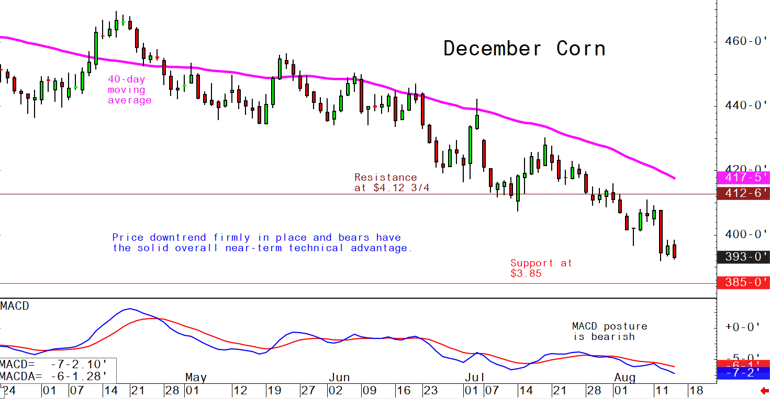
Wheat
Fundamental Recommendation: Like corn wheat is heading into a period when the market typically adds weather risk premium and the dryness in key US growing regions could justify a larger-than-normal addition heading into the 2026 growing season. However, fundamentally, ample to almost burdensome world supply balances against the potential for weather issues. So, short-term headline risk remains two tailed, but our expectation is that prices will be lower a year from now. That said, in the short-term weather headline risk could push prices higher into the winter. Given our expectations, buying small delta calls and puts would express an expectation for an increase in volatility, or the potential for significantly higher or lower prices.

Fundamental Bullish Factor – Rain delays are slowing winter wheat planting in Kansas.
Fundamental Bullish Factor – Dryness has also expanded in the high-protein growing areas of the US, supporting protein premiums.
Fundamental Bearish Factor – IGC increased world output estimates in late October
Fundamental Bearish Factor – Exporting countries expected to produce record crops in 2025/26, amplifying the ample world supply.
Fundamental Swing Factor – The Global Grains conference will bring a round of fresh supply and demand presentations and potential shift in expectations from a substantial portion of the Black Sea grain industry.
Fundamental Swing Factor – Peak La Nina could drive changing weather patterns, potentially drying down Australia and Argentina, but this remains low probability.

Technical Recommendation: Sideways to Lower.

Technical Bullish Factor – Markets are short-term oversold and due for upside correction.
Technical Bearish Factor – SRW and HRW prices well below key 40-day moving averages.
Technical Bearish Factor – SRW and HRW prices in downtrends on daily charts.
Technical Bearish Factor – Down-trending corn market is bearish for wheat.

Wheat (continued)

CBOT Wheat Technicals
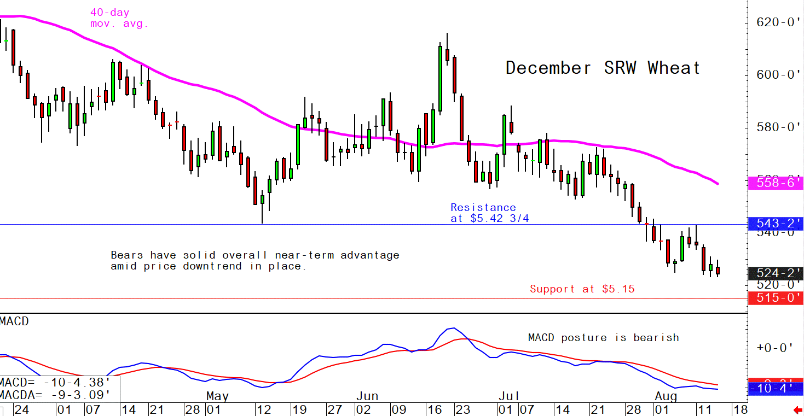

Soybeans
Fundamental Recommendation: Our initial reaction to the Chinese announcement is “trust but verify” on the performance against the contract. Analysts estimate Chinese buyers followed through on roughly three-quarters of the commitments made under the “Phase One” deal and Chinese hog economics have deteriorated due to the tariffs imposed by the Trump Administration, cutting Chinese import demand. However, the deal is only likely to impact US basis levels as the US commitments will offset purchases from Brazilian sources, allowing those exporters to backfill the customers that the US loses because it is shipping to China. We still believe the SA crop is the key driver of prices going forward and improving conditions will drive prices lower. However, given the freshness of the news, we are not as comfortable putting out a precise target this week but will work through the analysis and have an updated price forecast and specific recommendations next week.

Fundamental Bullish Factor – Resumption of Chinese purchases will support basis not flat price
Fundamental Bullish Factor – Borad crush margins seem to have stabilized around $1.50 per bushel,
Fundamental Bearish Factor – Chinese import demand has slowed due to deterioration in hog profitability
Fundamental Bearish Factor – Increased rainfall forecast for Mato Grosso
Fundamental Swing Factor – The development of La Nina
Fundamental Swing Factor – Potential decline in Chinese pork production could limit world soybean demand.

Technical Recommendation: Sideways.

Technical Bullish Factor – Prices now above key 40-day moving average.
Technical Bullish Factor – Soybean meal market now performing much better.
Technical Bullish Factor – MACD indicator turns bullish.
Technical Bearish Factor – Slumping corn and wheat markets are bearish for beans.
Technical Bearish Factor – Longer-term charts are not friendly for beans.

Soybeans (continued)

CBOT Soybeans Technicals
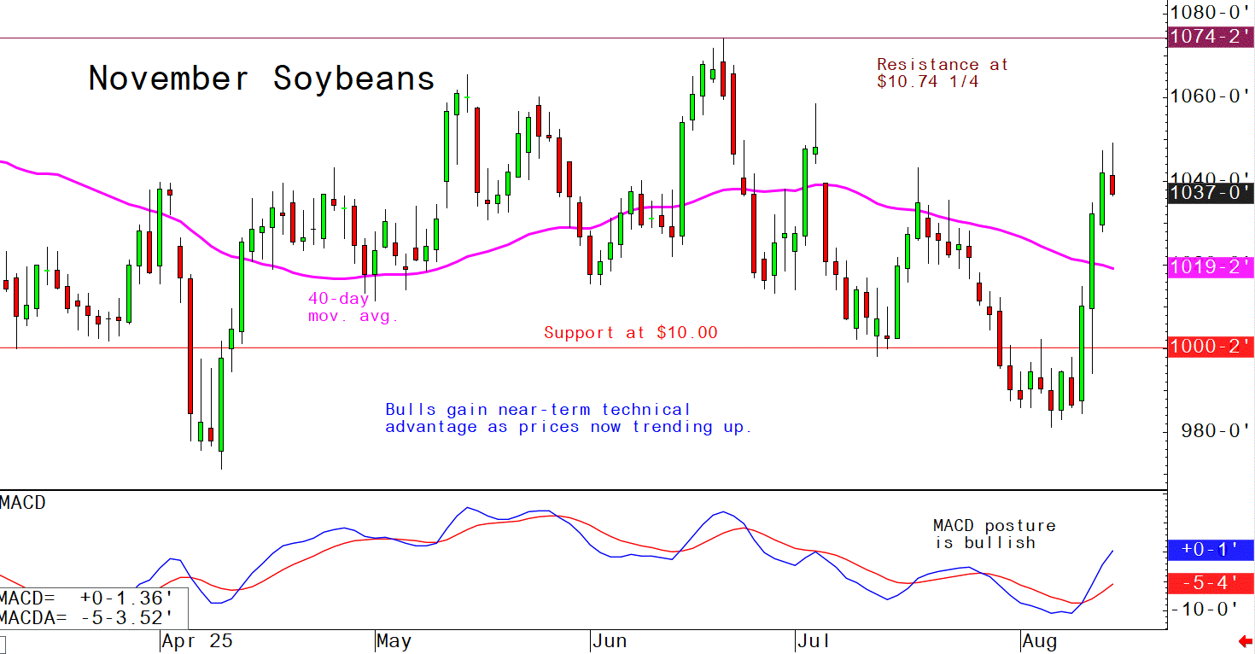
Soybean Meal
Fundamental Recommendation: The Chinese announcement will have a meaningful impact on the US soybean meal market. At the same time, the recent announcement by Bill Gates could reduce biofuel efforts cutting the potential for overproduction in soybean meal, which has pressured prices. That said, the lower prices drove record consumption, so it is likely feed rations may get a little tighter in reaction to higher prices, leaving us marginally bullish on flat prices for protein meals, but bullish for basis across the complex. Given the freshness of the news, we are not as comfortable putting out a precise target this week but will work through the analysis and have an updated price forecast and specific recommendations next week.

Fundamental Bullish Factor – Shift in biofuel policy priorities could lead to reduction in meal production
Fundamental Bullish Factor – Resumption of Chinese purchases tightens US domestic market
Fundamental Bearish Factor – Chinese pork demand slowing, potentially reducing Chinese soybean meal use.
Fundamental Bearish Factor – Improving growing conditions in Argentina ahead of planting

Technical Recommendation: Sideways to Higher.

Technical Bullish Factor – Prices now trending up on daily bar chart.
Technical Bullish Factor – Prices above key 40-day moving average.
Technical Bullish Factor – Spreaders are unwinding short meal, long bean oil spreads.
Technical Bearish Factor – Market is short-term overbought, technically.
Technical Bearish Factor – Longer-term charts are not bullish.

Soybean Meal (Continued)

CBOT Soybean Meal Technicals
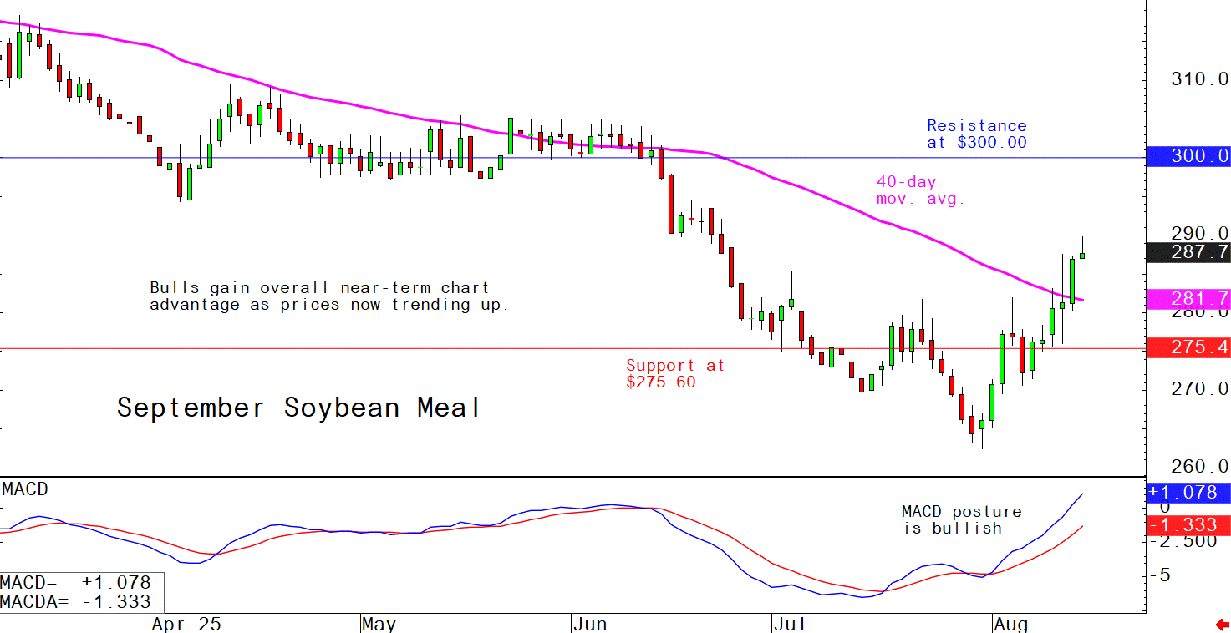

Soybean Oil
Fundamental Recommendation: Cross currents fundamentally, the Chinese announcement reduces the volume of beans available to the domestic market supporting soybean complex basis levels. At the same time, Bill Gates announcement that “Climate Change” will not end the world in a decade and in fact humanity will thrive, suggests the wind is coming out of the potentially stalled world-wide effort to drive SAF consumption. Still believe the SA crop will force the complex lower and if doubts about US biofuel policy take root, soybean oil could lead the product side of the complex lower. Given the freshness of the news, we are not as comfortable putting out a precise target this week but will work through the analysis and have an updated price forecast and specific recommendations next week.

Fundamental Bullish Factor – US inventories remain tight despite record crushing volumes
Fundamental Bullish Factor – Resumption of Chinese purchases will tighten domestic soybean market
Fundamental Bearish Factor – Delays in implementation of Brazilian biofuel mandates raise export competition
Fundamental Bearish Factor – Bill Gates admission that humanity will thrive in the coming years, despite rising world temperatures

Technical Recommendation: Sideways to Lower.

Technical Bullish Factor – Solid chart support levels just below the market.
Technical Bullish Factor – Rallies in soybeans and meal will limit downside in bean oil.
Technical Bullish Factor – Weekly chart is still friendly.
Technical Bearish Factor – Price downtrend in place on daily chart.
Technical Bearish Factor – Prices below key 40-day moving average.
Technical Bearish Factor – Slumping crude oil prices bearish for bean oil.

Soybean Oil (Continued)

CBOT Soybean Oil Technicals
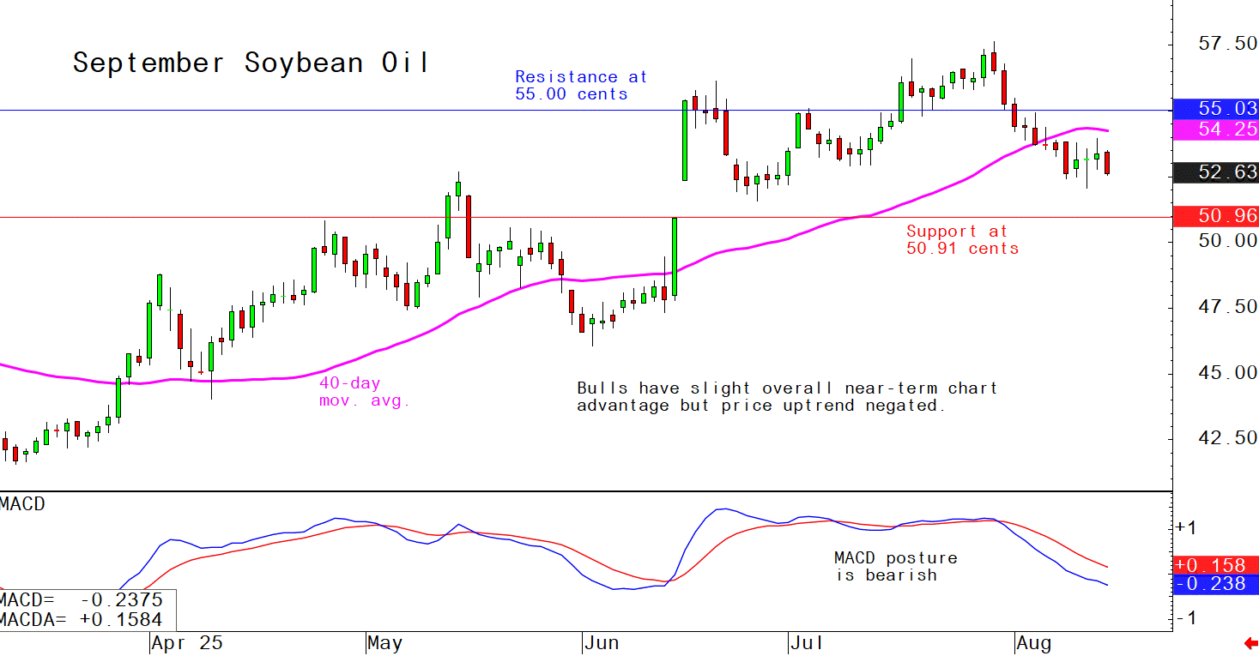

Agricultural Prices

